

Navigation in Virtual Reality Space

Concepts of Navigation Methods

**IP5 Project of**

**Bär Dominic**

**Groux Marcel**

**FHNW**

**University of Applied Sciences**

**Degree Course: Computer Science / iCompetence**

**Supervising Lecturers: Arisona Stefan, Marcin Simon**

**Windisch, 22. January 2017**

Clarification of Honest

Hereby I declare to have written the present IP5 Project independently, without help of a third party and only under the usage of the declared sources.

|  |  |  |
| --- | --- | --- |
| Brugg, 22 January 2017 |  | Brugg, 22 January 2017 |
| Place, date |  | Place, date |
|  |  |  |
| Signature Dominic Bär |  | Signature Marcel Groux |

Summary

With the commercially available HTC Vive it is possible to dive into virtual dream worlds and experience them in person. Such virtual worlds are beautiful, but there are factors that make these worlds less immersive than the real world. One of these factors is the limited tracking space. This limited tracking space can be overcome with new inventive navigation methods.

To find such navigation methods we researched various virtual reality papers which mostly used older non commercially available equipment. We took some of their ideas and created a navigation method prototype containing five different methods: Teleportation, jumping, walking in place, walking by leaning and scaled walking.

With the created prototype we tested each navigation method on quality factors like speed, ease of learning or the presence. The results of those quality aspects helped us making suggestions for the usage of the navigation methods.

The suggestions give insights and a possible edge to virtual reality developers.

Preface

We appreciate it to be able to work on such a fascinating project as our IP5 project. We are thankful to our coaches Simon Marcin and Prof. Dr. Stefan Arisona for all their thought-provoking inputs and their constructive feedback.

Furthermore, we are thankful to Michael Läuchli and Stefan Mettler of the ‘Explorative Navigation in Virtual Reality’ project team for their collaboration in sharing insights and constructive comments. Special thanks go to all 14 participants of our testing sequences.

Index

1 Introduction (Dominic) 1

1.1 What has been achieved? 1

1.2 Why has it been done? 1

1.3 How has it been achieved? 1

1.4 Readers Guide: How is the document constructed? 1

2 Initial Position 2

2.1 Introduction 2

2.2 Application domain 2

2.3 Overall scenario 2

2.3.1 Target audience 2

2.4 Project Goals 2

2.4.1 Navigation Methods 3

2.5 Project Scope 3

2.6 Limitations and Assumptions 3

2.6.1 Limitations 3

2.6.2 Assumptions 3

3 Research 4

3.1 Introduction 4

3.2 Problem 4

3.3 Researched Navigation Methods 4

3.3.1 Implemented Navigation Methods 5

3.3.2 Other Navigation Methods 7

3.3.3 Researched Parameters 10

3.4 Technical Research 11

3.4.1 Game Engines 11

3.4.2 VR Headsets 12

4 Implementation 14

4.1 Introduction 14

4.2 Teleport 14

4.3 Jumping 14

4.3.1 Concept & Idea 14

4.3.2 Parameters 14

4.3.3 Implementation 15

4.4 Walking in Place 18

4.4.1 Concept & Idea 18

4.4.2 Parameters 18

4.4.3 Implementation 18

4.5 Walking by Leaning 22

4.5.1 Concept & Ideas 22

4.5.2 Parameters 22

4.5.3 Implementation 22

4.6 Scaled Walking 25

4.6.1 Concept & Idea 25

4.6.2 Parameters 25

4.6.3 Implementation 25

5 Testing 27

5.1 Introduction 27

5.2 Testing Scenario 27

5.3 Experience with Virtual Reality 27

5.4 Ease of Learning 27

5.4.1 Teleport 28

5.4.2 Jumping 29

5.4.3 Walking in Place 29

5.4.4 Walking by Leaning 30

5.5 Pick & place 30

5.5.1 Teleport 31

5.5.2 Jumping 32

5.5.3 Walking in Place 33

5.5.4 Walking by Leaning 34

5.6 Jump’n’Run 36

5.6.1 Teleport 37

5.6.2 Jumping 38

5.7 Ease of Use 40

5.8 Problems during testing 41

6 Conclusion 42

6.1 Introduction 42

6.2 Insights 42

6.2.1 Speed 42

6.2.2 Ease of Learning 42

6.2.3 Ease of Use 43

6.2.4 Information Gathering 43

6.2.5 Accuracy 43

6.2.6 Presence 43

6.3 Suggested scenarios for Navigation Methods 43

6.3.1 Teleportation 43

6.3.2 Jumping 43

6.3.3 Walking in Place 43

6.3.4 Walking by Leaning 44

6.4 Conclusion 44

7 Further Steps 45

7.1 Introduction 45

7.2 Marketplace UE4 / Unity3D 45

7.3 Graphical Navigation Menu / UI 45

7.4 Composition of Navigation methods 45

7.5 Teleportation – turn when meeting chaperone 45

7.6 Deceleration when close to walls and obstacles. 46

8 Reflection 47

8.1 Introduction 47

8.2 Lessons Learned 47

8.2.1 Dominic Bär 47

8.2.2 Marcel Groux 47

8.3 Time Management 48

8.4 Collaboration 49

8.4.1 Team Internal Collaboration 49

8.4.2 Collaboration with Coaches / Clients 49

8.4.3 Collaboration with the ‘Explorative Navigation in Virtual Reality’ project team 49

9 Index of Literature 50

L1. Internet 50

L2. Existing Projects 50

10 Index of Figures 51

10.1 Figures 51

10.2 Tables 52

10.3 Chartpairs 53

A. Attachment 1

A1. Project Agreement 1

A2. Test Procedure 3

A3. Testing Survey 6

A4. Testing Survey Results 15

A4.1. Ease of Learning 15

A4.2. Pick & Place 17

A4.3. Jump’n’Run 19

A4.4. Ease of Use 21

1. Introduction (Dominic)

This chapter contains an overview of the project. It describes what has been accomplished with the project and which topics are covered.

## What has been achieved?

Within the scope of this project a prototype for methods of navigation in the virtual reality space has been created. This prototype contains five different methods of navigation covering the two main groups of navigation methods, teleporting and walking. From these five navigation methods were four thoroughly tested.

To further use this prototype in upcoming projects a concept containing suggestions for using the different navigation methods has been created. We also discuss further possible enhancements to the prototype

## Why has it been done?

The prototype was created to analyse the navigation methods in the virtual reality and to create suggestions on which navigation method to use in which environment and / or scenario. The main problem with navigation methods lies within the question of how to navigate without needing to step out of the detected area, so that you can move in the virtual world as in the real world.

At this very point in time virtual reality devices are commercially available and thus we are able to research with them without building up an overly expensive setup [1] [3] [4].

## How has it been achieved?

The creation of the prototype can be divided into two parts. In the first part we research many different navigation methods and their used parameters. Based on those we choose certain navigation methods we implement and created the concept and idea how we imagined them to be implemented. The second part covers the implementation of the prototype for the chosen navigation methods.

Regarding the technical aspects, we used the game engine UnrealEngine 4 and the virtual reality device HTC Vive.

## Readers Guide: How is the document constructed?

The document consists of two parts. The first one contains the theoretical aspects covering the problem, the goals and the research. The second part addresses the practical aspects of implementation, testing and suggestions.

# Initial Position

## Introduction

In this chapter the initial position of the project will be introduced. The Application domain will be described and an overall scenario will be shown. Furthermore, the project goals and scope will be stated.

## Application domain

In a first instance the project was created as a proof of concept for the University of Applied Science FHNW and has currently no direct application domain. In a second instance the project could be published and find its usage in the development of virtual reality applications or games.

## Overall scenario

The project covers the research and analyzation of navigation method and the development of a prototype for navigation methods in the virtual reality. The overall goal is to create a concept of different navigation methods with suggestions for each method and their suitability in different scenarios.

### Target audience

The creation of the prototype is targeted for creators of virtual reality applications and / or games used in a home environment.

## Project Goals

The goal of this project is the generation of a concept about the navigation in the Virtual Reality space. The concept is based on a scientific research and should address the questions of the suitability for different navigation methods and the corresponding parameters (e.g. camera angle/area, scaling in space, …) within specific scenarios, which are to be determined.

Finally, the concept contains a thorough scientific analysis of VR navigation and its parameters, elaborated in a scientific approach and reflecting the current state of research of the Virtual Reality Community as far as possible.

The navigation methods, elaborated in the concept, should be implemented as a template for different scenarios and be tested thoroughly. Such that it can be shown which navigation methods are suited best for different scenarios. Thereby it is to bear in mind that the navigation that we are reviewing should be possible to use in a home-user-environment.

### Navigation Methods

The following navigation methods will be elaborated in the prototype:

* Walking in Place
* Walking by Leaning
* Scaled Walking
* Teleporting
* Jumping

Further details to each navigation method will be given in chapter ‘3.3 Research Navigation Methods’.

## Project Scope

Project contains the following emphases:

* Research of navigation methods and their respective parameters
* Creation of a concept of how to implement the navigation methods
* Implementation of the chosen navigation methods
* Testing and analysis of the implemented navigation methods

## Limitations and Assumptions

### Limitations

We researched far more navigation methods than we have had to implement and test. Due to that we had to limit the number of navigation methods we implement in our prototype. We chose the navigation methods that are commonly used, namely the teleportation method, and those that interested us personally the most.

Furthermore, we had to cancel the dynamic walking navigation method stated in the project agreement due to not having the time to implement it as well.

### Assumptions

There were no assumptions to be held.

# Research

## Introduction

In this Chapter we discuss the problem of our project and show results of our research in the field of the application domain

## Problem

The community provides a variety of implementation and methods for the navigation in the Virtual Reality space. Many of those couldn’t be tested and analysed scientifically. Furthermore, the already existing scientifically elaborated concepts are not necessarily suited for the new VR Hardware and the User- Space available for the VR-setup, like the HTC Vive or the Oculus Rift, [6] and the usage in a productive application with users that have varying know-how and experience in Virtual Reality.

## Researched Navigation Methods

As described in chapter *‘2.6 Limitations and Assumptions’* we researched far more navigation methods than we could implement in the prototype. Therefore, the chapter is divided into two parts either covering the implemented methods or the various other researched navigation methods.

Each navigation methods contains the following properties:

|  |  |
| --- | --- |
| Description | Short description of the navigation method |
| Physical Translocation | Does the user need to walk in the physical space? |
| Physical Movement | Does the user need to do move his body in order to activate a navigation method. |
| Parameters | List of potentially needed parameters |
| Problems | List of potential problems concerning the implementation and usage of the method. |

Table 1 - Description of the navigation method properties

### Implemented Navigation Methods

#### Pointed Teleportation

|  |  |
| --- | --- |
| Description | The user points towards a location he wants to teleport to. With clicking on a button he teleports to that location. |
| Physical Translocation | No, the user does not need to move around in the room. |
| Physical Movement | No, the only needed movement is to point towards a location and pressing a button. |
| Parameters | * Location * Camera direction * Speed of the teleport |
| Problems | * Camera direction after teleport (wall collision) * Camera transition |

Table 2 - Properties of Pointed Teleportation

#### Jumping

|  |  |
| --- | --- |
| Description | The user jumps in place. |
| Physical Translocation | No, the user does not need to change the location in the room in order to trigger the virtual movement. |
| Physical Movement | Yes, the user needs to jump in place in order to trigger the virtual movement |
| Parameters | * Location * Location (head) * Camera direction * Scaling |
| Problems | * Probably needs to be combined with other navigation methods * Physical exhaustion |

Table 3 - Properties of Jumping

#### Walking in Place (WIP)

|  |  |
| --- | --- |
| Description | The user walks in place without changing his location in the room. |
| Physical Translocation | No, due to not moving in the room the physical location of the user does not change. |
| Physical Movement | Yes, the user needs to move his arms in a walking movement. |
| Parameters | * Speed * Acceleration * Deceleration * Camera Direction |
| Problems | * Wall Collision in the virtual reality * When does the character start to walk * Which inputs does the user have to give * Motion sickness of the user |

Table 4 - Properties of Walking in Place

#### Walking by Leaning

|  |  |
| --- | --- |
| Description | The user leans towards the direction he wants to walk to. |
| Physical Translocation | No, due to not moving in the room the physical location of the user does not change. |
| Physical Movement | Yes, the user has to lean in order to trigger the virtual movement. |
| Parameters | * Location * Location (Head) * Speed * Acceleration * Deceleration * Camera Direction * Scaling |
| Problems | * Wall Collision * Detection of leaning degree * Scale-rate * Motion sickness |

Table 5 - Properties of Walking by Leaning

#### Scaled Walking

|  |  |
| --- | --- |
| Description | The user walks inside the predefined space of the room. His physical translocation will be scaled up in the virtual reality space. |
| Physical Translocation | Yes, the user needs to walk in the room to activate the virtual movement |
| Physical Movement | Yes, the user has to lean in order to trigger the movement. |
| Parameters | * Location * Speed * Acceleration * Deceleration * Camera Direction * Scaling |
| Problems | * Wall Collision * Scale-rate * Motion sickness |

Table 6 - Properties of Scaled Walking

### Other Navigation Methods

#### Walking

|  |  |
| --- | --- |
| Description | The user walks inside a given space in the room. [7] |
| Physical Translocation | Yes, the virtual location is based on the physical location in the room. |
| Physical Movement | Yes, the user needs to walk around in order to activate the virtual movement. |
| Parameters | * Location * Speed * Acceleration * Deceleration * Camera direction |
| Problems | * Wall collision |

Table 7 - Properties of Walking

#### Dynamic Walking

|  |  |
| --- | --- |
| Description | The user walks like in scaled Walking. The intention of the user is detected. [8] |
| Physical Translocation | Yes, the virtual position is based on the user’s physical location. |
| Physical Movement | Yes, the user needs to walk in the physical room. |
| Parameters | * Location * Speed * Acceleration * Deceleration * Camera direction * Scaling |
| Problems | * Wall collision * Scale-rate * Motion sickness |

Table 8 - Properties of Dynamic Walking

#### Auto Walking

|  |  |
| --- | --- |
| Description | The user looks down at his feet and starts to walk. |
| Physical Translocation | No, the user does not need to change his physical location |
| Physical Movement | No, the user needs only to look at his feet in order to trigger the virtual movement. |
| Parameters | * Speed * Acceleration * Deceleration * Scaling |
| Problems | * Wall collision * When does it start to walk? * When does it stop to walk? * Scale-rate * Motion sickness |

Table 9 - Properties of Auto Walking

#### Walking by Button

|  |  |
| --- | --- |
| Description | The user presses a button on the controller to walk. |
| Physical Translocation | No, no physical change of the location by the user in the room needed. |
| Physical Movement | No, no physical movement besides pressing a button needed. |
| Parameters | * Speed * Acceleration * Deceleration * Scaling |
| Problems | * Wall collision * Scale-rate * Motion sickness |

Table 10 - Properties of Walking by Button

#### Gaze-directed Teleportation

|  |  |
| --- | --- |
| Description | The user looks towards a location he wants to teleport to. With pressing a button, he teleports to that location. |
| Physical Translocation | No, no physical movement required to activate the method. |
| Physical Movement | No, pressing a button is the only needed physical action by the user. |
| Parameters | * Location * Camera direction * Speed of teleport |
| Problems | * Camera direction after teleporting (wall collision) * Camera transition |

Table 11 - Properties of Gaze-directed Teleportation

#### Room-to-Room-Teleportation

|  |  |
| --- | --- |
| Description | The user selects a room he wants to teleport to. By clicking a button, he teleports to the selected room. His location inside the room is dependent of the current location in the physical space. |
| Physical Translocation | No, the user does not need to walk in the physical space. |
| Physical Movement | No, no physical actions by the user needed. |
| Parameters | * Location * Camera direction * Speed of teleport |
| Problems | * Combining with other methods for walking in the rooms * Camera transition |

Table 12 - Properties of Room-to-Room-Teleportation

#### Zoomed Teleportation

|  |  |
| --- | --- |
| Description | The user looks into the direction he wants to teleport. With clicking a button, he zooms in on that location. |
| Physical Translocation | No, the user is not required to walk in the physical space. |
| Physical Movement | No, no physical actions by the user needed. |
| Parameters | * Location * Camera direction * Speed of zooming |
| Problems | * Wall collision * Camera transition |

Table 13 - Properties of Zoomed Teleportation

#### Climbing

|  |  |
| --- | --- |
| Description | The user climbs up a wall by using his hand to pull himself up. |
| Physical Translocation | No, the physical location of the user does not change. |
| Physical Movement | Yes, the user is required to move his hand as if he is climbing up a wall. |
| Parameters | * Location (head) * Camera direction * Scaling |
| Problems | * Probably needs to be combined with another method. |

Table 14 - Properties of Climbing

#### Flying

|  |  |
| --- | --- |
| Description | The user flies by using his hand / controllers like wings to navigate horizontally and vertically. |
| Physical Translocation | No, no translocation in the physical room required. |
| Physical Movement | Yes, the user uses his hand / arms like wings of a plane. |
| Parameters | * Location * Speed * Acceleration * Deceleration * Camera direction * Scaling |
| Problems | * Wall collision * Scale-rate * When does it start to fly? * Motion sickness |

Table 15 - Properties of Flying

#### Flying II

|  |  |
| --- | --- |
| Description | The user flies through the virtual world by pressing buttons |
| Physical Translocation | No, the user does not need to change the physical location. |
| Physical Movement | No, no physical movement besides pressing the buttons needed. |
| Parameters | * Speed * Acceleration * Deceleration * Scaling * Camera direction |
| Problems | * Wall collision * Motion sickness |

Table 16 - Properties of Flying II

### Researched Parameters

The following parameters we researched are possible to be used to track and change for different Navigation methods

#### Location / Rotation (Head-Gear)

This parameter gives us access to the current location of the Head Mounted Device and can be used for scaled walking. It also gives access to the current rotation of the Head Mounted Device, which can be used for a leaning navigation method, also for determining where the User looks at.

#### Camera Direction

The camera direction can be determined from the Head Mounted Device rotation. It is used for locomotion of the user in the current gaze (camera) direction.

#### Location/ Rotation (Hand-Controller)

The Hand Controllers can especially be used to detect special navigation methods like walking in place, where the User swings his arms to move. Or even swimming motions to swim in virtual water.

#### Speed

The speed is an important factor for many movement methods, it’s critical that it does feel comfortable for the specific use case (just fast enough and just precise enough), for which it should be tested and doesn’t cause motion sickness.

#### Acceleration/ Deceleration

Acceleration and Deceleration comes to mind when working with walls that are impassable, so that the user is in a virtual environment and is blocked by walls or other obstacles when he was moving. Instead of just coming to an abrupt halt it should decelerate slowly and then stop, preventing motion sickness.

The parameter should be researched more thoroughly when the last touch for a movement Method is required.

#### Scaling

Scaling of the real world movement is possible to achieve by measuring the location change of the Head Mounted Device.

## Technical Research

The following subchapter will focus on the technical side of our research regarding the game engines and the virtual reality hardware.

### Game Engines

#### Unity 3D

Unity is a multi-platform game engine developed by Unity Technologies. It is commonly used for the development of video games for computers, consoles and mobile devices. Unity itself describes it as the world’s largest creative community and the number one game development platform[1].

The included WYSIWYG editor makes it easy to get started and develop your first project. Another useful resource for an easy start is the rapidly growing community, a variety of tutorials and a wide range of plugins and extensions freely obtainable or purchasable in the asset store.

As for the programming language, the commonly used language is C#, but other languages like JavaScript are supported as well.

Among the normal purchasable versions, Unity offers also a free-to-use version. However, when using the free version, they automatically include a predefined Unity splash screen prior to your game. If your created game or application reaches a certain amount of revenue you are forced to get one of the paid versions. There are no royalty payments.

#### UnrealEngine4

The UnrealEngine4 is a game engine created by epic games.

One of the outstanding advantages of unreal is the blueprint system, which allows you to combine blueprints of objects and properties with functional statements in a visual way.

As for the programming language, the commonly used languages C++ and UnrealScript (a java-based object-oriented script language).

Epic Games delivers no purchasable version of the UnrealEngine4. To compensate the free usage of the engine they ask for a 5% royalty payment after reaching $3000.- of revenue per product per quarter. However, there are some exceptions for certain types of projects. « Pay no royalty for film projects, contracting and consulting projects such as architecture, simulation and visualization. »

#### Comparison & Reason of Choice

Compared to Unity 3D the UnrealEngine4 loses in the amount of supported platforms. Unity supports a wide and still growing range of platforms, while Unreal only supports the big names.

The Unity 3D Asset Store and the UnrealEngine4 Marketplace have very little in common. The Asset Store focuses on plugins, extensions and assets, while the Marketplace strongly focuses on the distribution of asset content.

Another difference between the two engines is the blueprint system of the UnrealEngine4. With this system you can create the entire project without writing code by combining blueprints with functional statements.

Due to personal reason and a greater interest we chose to work with the UnrealEngine4.

### VR Headsets

#### HTC Vive

The HTC Vive system contains the Head Mounted Device (HMD), two controllers and two base-stations.

The HMD of the HTV Vive has a visual field range of 110° (diagonally), a resolution of 2160 x 1200 overall or 1080 x 1200 for each eye and an image refresh rate of 90 Hz. The 32 built-in sensors allow for a 360° movement tracking. With the front camera it is also possible to add physical objects into the virtual world.

The measurements of the position are calculated by the two base-stations mounted to the ceiling of the room. Each base-station contains a sensor to track the position of the HMD. The position of the HMD is measured with a gyroscope and an accelerometer. The two base-stations allow for a quadratic area with adjustable side length depending on the distance between the stations.

The user inputs are controlled by two hand controllers, one for each hand. The 24 sensors of the controllers allow for precise movement tracking. The multifunctional trackpad and the double-staged triggers with haptic HD-Feedback allow an entirely new virtual reality experience.

To connect the HTC Vive with a computer are two HDMI-, two USB-, and one audio slot needed. The audio slot is needed to connect headphones to the audio slot attached to the HMD.

#### Oculus Rift

The Oculus Rift system contains the Oculus Rift, an Oculus Sensor, an Oculus Remote and an Xbox One Controller. The system can be expanded by the newly released Oculus Touch, two controllers similar to the ones the HTC Vive already has included in the base set-up.

The Oculus Rift has like the HTC Vive a visual field range of 110° (diagonally), a resolution of 2160 x 1200 overall or 1080 x 1200 per eye and an image refresh rate of 90 Hz.

The tracking of movement is measured with a gyroscope, an accelerometer and a magnetometer. The tracking of position is handled by the external Oculus Sensor.

The user inputs are handled either by a normal Xbox One Controller or the newer Oculus Touch.

#### Comparison & Reason of Choice

The two base-stations of the HTC Vive enable a wider tracking range than the Oculus Sensor The HTV Vive has a tracking range of 15 x 15 feet, while the range of the Oculus rift is limited to 11 x 5 feet.

The technical details like visual field range or resolution for both systems are more or less the same, with the only significant difference being the magnetometer in the movement tracking of the Oculus Rift.

Due to the wider tracking range and the available controllers we chose to use the HTC Vive as our virtual reality device. Another determinant factor was the better comfort of the HTC Vive Head Mounted Device.

# Implementation

## Introduction

The following chapter discusses how we imagined the navigation methods, which parameters were used and how we finally implemented them.

## Teleport

We did not implement the teleportation method. We used the teleportation method of an already existing project which we based our project on.

The project can be found under the following address:

<https://bitbucket.org/mordentral/vrexppluginexample>

## Jumping

### Concept & Idea

When the User jumps, the position of the user changes a certain distance forward. There can be many use cases for this, a jump and run could be made like this.

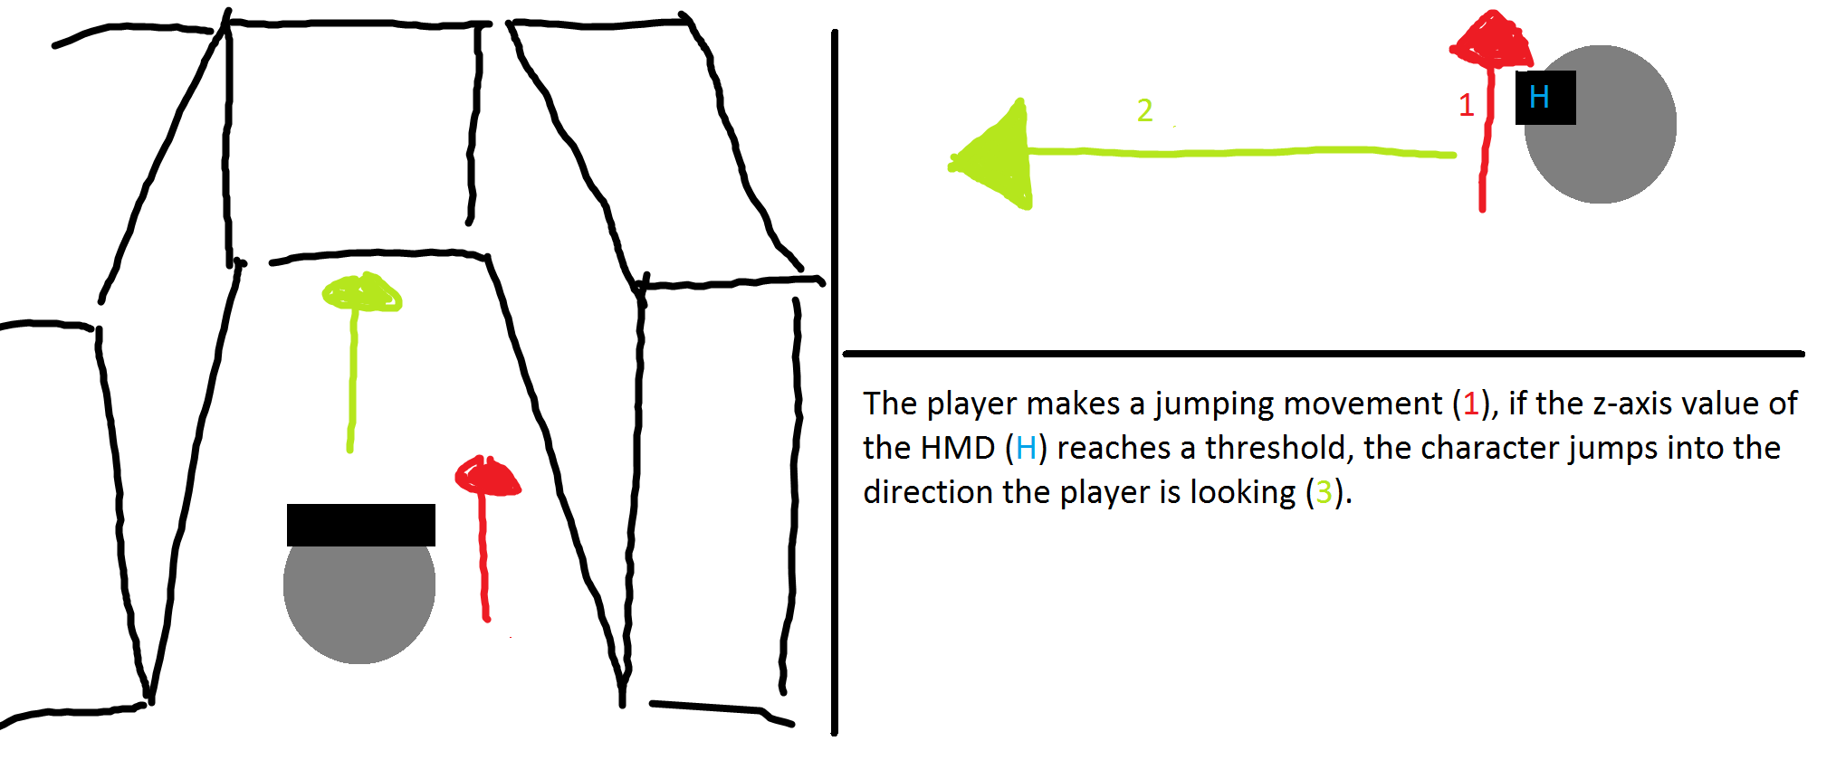

Figure 1 - Jumping concept draft

### Parameters

The following parameters are used in this method.

* Rotation HMD
* Location HMD
* Time

### Implementation

After an initial implementation we decided to use a jump indicator for the user. It is spawned in the gaze direction of the player.

We came to an implementation problem that we couldn’t get around, we tried to fix the position of the indicator to the camera of the player controller. However, we couldn’t get it to work. So instead we spawned an emitter regularly at the target position.

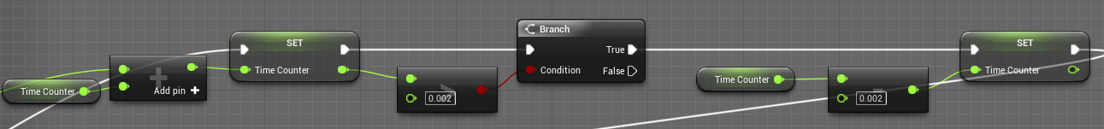

Figure 2 - Measuring Time

In the Jumping we need to measure zValues in certain time intervals.

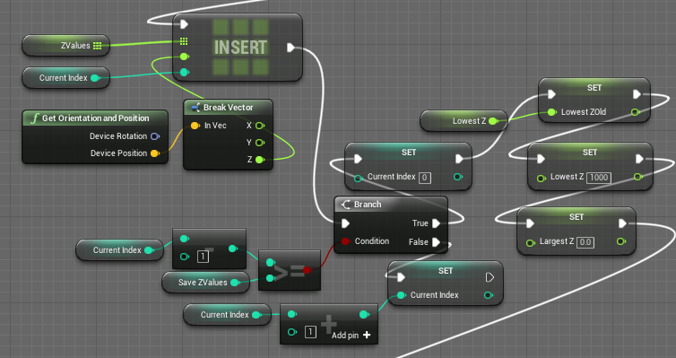

Figure 3 - Creating an array of ZValues

If the current Index is at that the highest point and if it is so we reset the index back to the starting point, we save the LowestZ Variable, that we found in earlier steps and reset LowestZ and LargestZ.

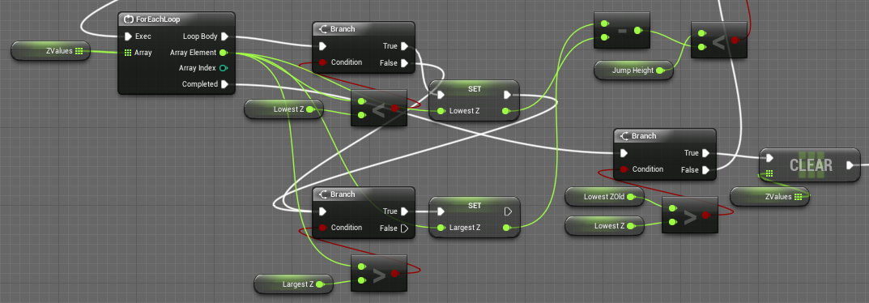

Figure 4 - Iterating and Evaluating

We now iterate over the ZValues and find the largest and the lowest value, if there is a lower value found than the LowestZ that is saved the array gets cleared, because we only want to jump when the user is going in positive Z direction. If that’s not the case, we compare the jump height to the difference between the lowest and largest Z.

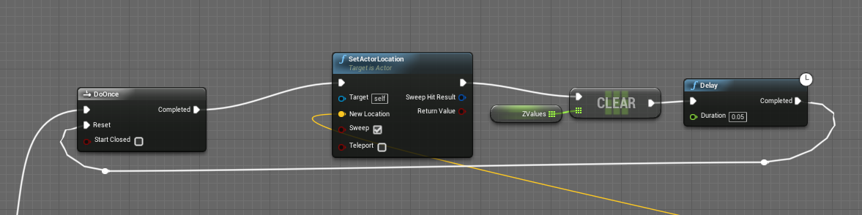

Figure 5 - Jump Height Detection

If the jump height is smaller than the detected difference, then the user jumps forward.

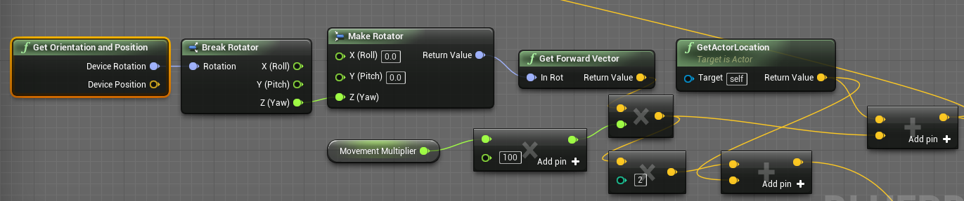

Figure 6 - Jumping height detection

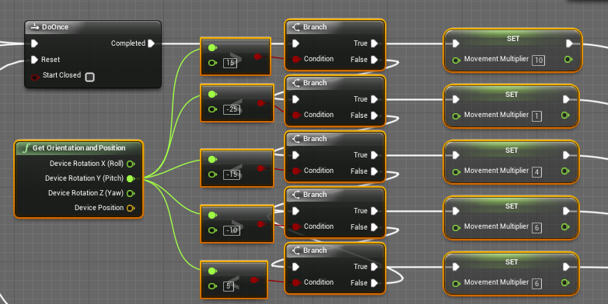

Figure 7 - Mulltiplier dependent on HMD pitch

If the jump height branch doesn’t evaluate to true, then the multiplier is set by checking the value of the HMD (Pitch), this is if you look close to your shoes or far to the horizon.

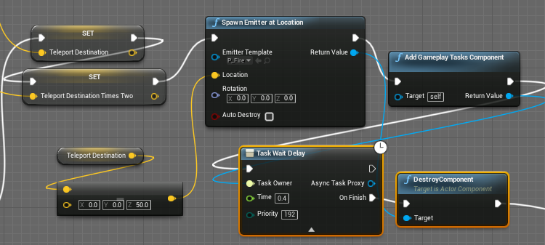

Figure 8 - Spawning a target indicator

In the end an emitter is spawned at the teleport location, this is refreshed only all 0.4 seconds.

## Walking in Place

### Concept & Idea

The user swings his arms in the same way he would when walking. The location of the controllers is tracked to determine the distance they covered. Then the character is locomoted. [6] [7] There are also possibilities to detect walking in place movements because of a movement measurement of the HMD [10]

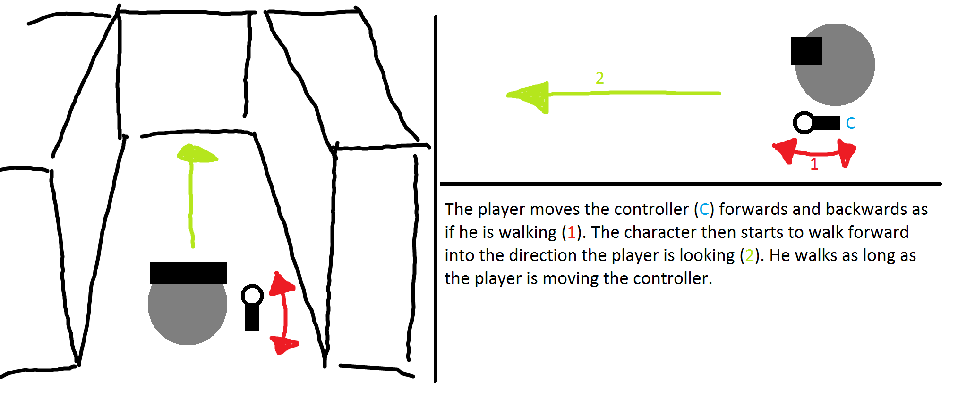

Figure 9 - Walking in place concept draft

### Parameters

The following parameters are used in this method.

* Speed
* Camera direction
* Controller position

### Implementation

Two different implementations were prepared to answer the question in what direction the Virtual player is locomoted. One implementation used the forward direction of the controllers, to determine the locomotion direction. The second implementation used the gaze direction of the Head Mounted Display. In the following you see the blueprint implementation of the Walking in Place movement method.

In the following we see an example implementation of the Walking in Place module that is controller oriented (the difference to HMD orientation is very small and can be found ). In the unreal project under Vive/MyViveFolder/MySimpleVive_PawnCharacter.

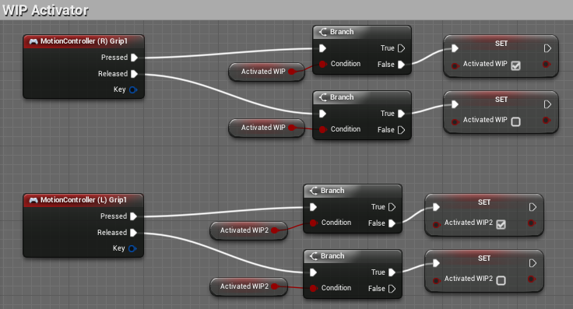

Figure 10 - Activator Walking in Place

First the walking in place needs to be activated, we used the grip button to activate it. (this is done as well for the Left MotionController.

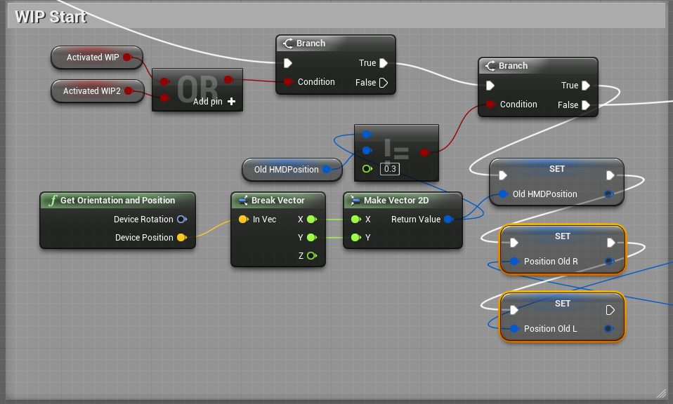

Figure 11 - Start Walking in Place

Then we determine if the HMD position is moved too much any movement that is done with the Left/Right Hand Controllers will be ignored. This is done to not detect any walking in place movement when the User is moving by walking in the real world.

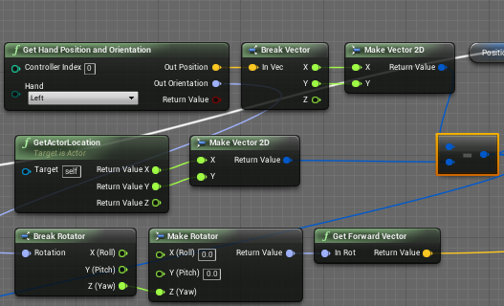

Figure 12 - Access Hand Position

We access the left Hand Position as well as the rotation and calculate the forward vector of the left Hand. We also need the Position of the Actor, that is the player’s current location, that we want to subtract from the hand position, since we only want to move the position when the position of the controller is changed relative to the player’s location.

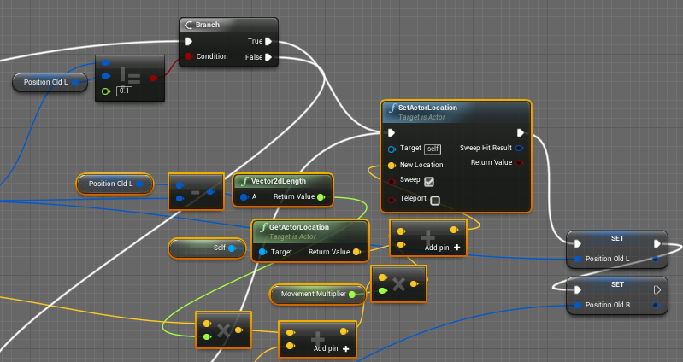

Figure 13 - Calculation of new location

As seen in the picture we compare the Left position of the controller with the old saved position of the controller if the difference between the two values is greater than 0.1, the locomotion will take place. And the Branch evaluates to true, the new location will be set and the old positions of the Left/ Right Hand Controllers will be saved.

The Marked orange part is here to calculate the new location of the player:

We see calculate the difference of the x, y value of the Left Hand controller position, then we calculate the length of the vector. This distance we multiply with the forward vector of the Left Hand Controller (we add to that the movement part calculated for the Right Hand Controller, which is similar to the above.), then we multiply with the movement multiplier, add the current location of the player to it and we have the new location that we locomoted to.

## Walking by Leaning

### Concept & Ideas

With walking by leaning the user leans towards a direction he wants to walk to. Once a certain threshold of the x-axis rotation is reached the virtual character begins to glide into that direction. The problem with that idea is that it is more a head rotation than a full body leaning.

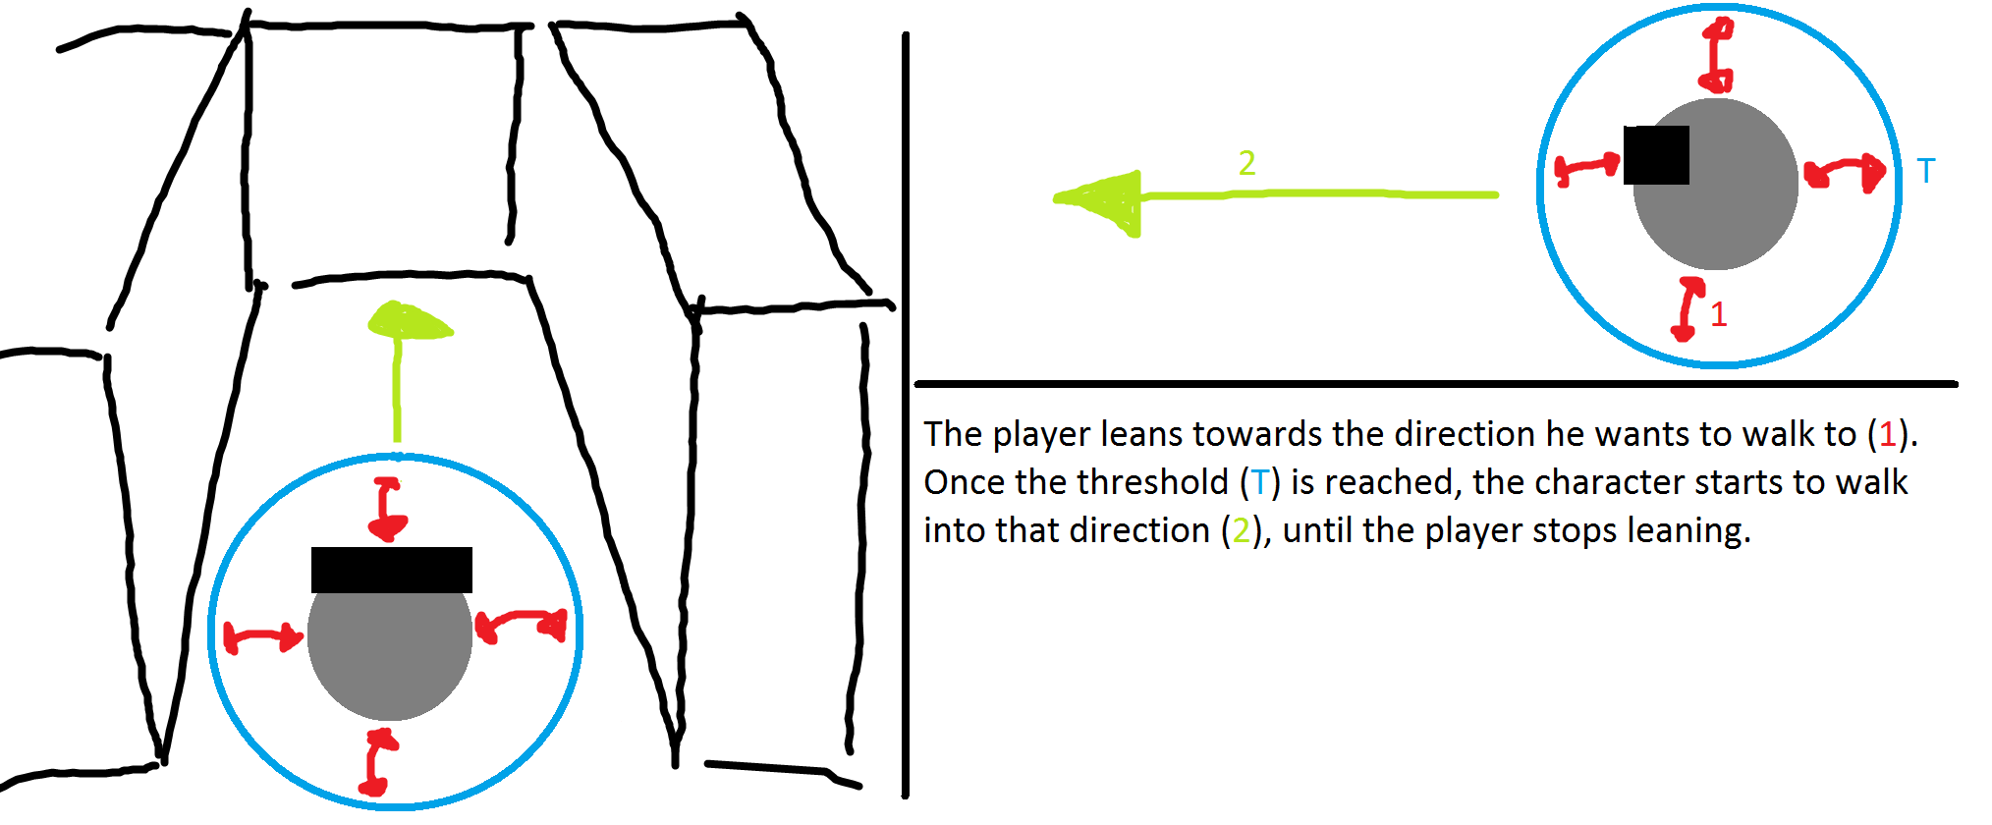

Figure 14 - Walking by leaning concept draft

### Parameters

The following parameters are used in this method.

* Speed
* Rotation HMD
* Location HMD
* Location controller

### Implementation

There are multiple versions that we implemented, we experimented first with a version that used only the rotation of the Head Mounted Device to check if the user was leaning.

The most important question here is, when does the character start to move?

In the first version we tried out different activation values for the angle of the Head Mounted Display. With that we discovered that, since the player is leaning extensively, he can’t really see where he’s going, if we set the activation value to near to the normal looking angle, the character would move unexpectedly. [6] Therefore, we implemented a version that we called “Ninja”, it locomotes the user when the controllers are behind the Head Mounted Device forward vector (the gaze direction of the user).

In the following section we are going to see the implementation of the Walking in Place Method called “Ninja”.

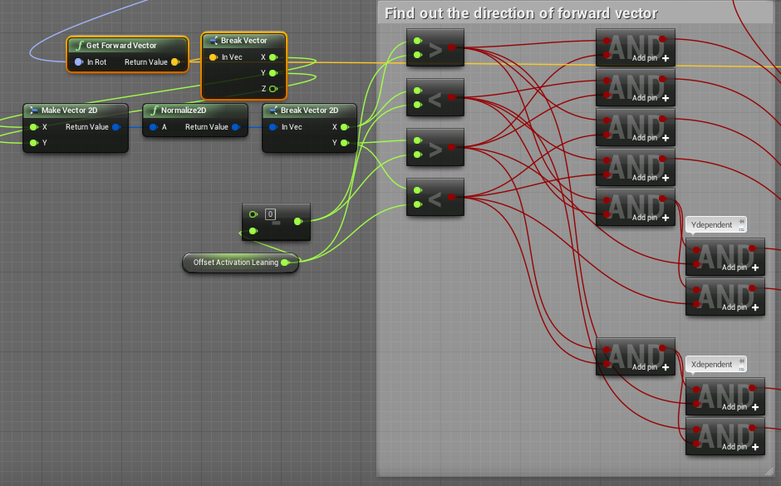

Figure 15 - Finding the forward vector of the HMD

We find out what has to be true, when the vector of the HMD is pointing in a certain direction. There are only 4 variants, however there are 4 more variants for when it’s only X dependent or only Y dependent. Depending on that the controllers position has to be either only greater or smaller for the X position or only greater or smaller for the Y position.

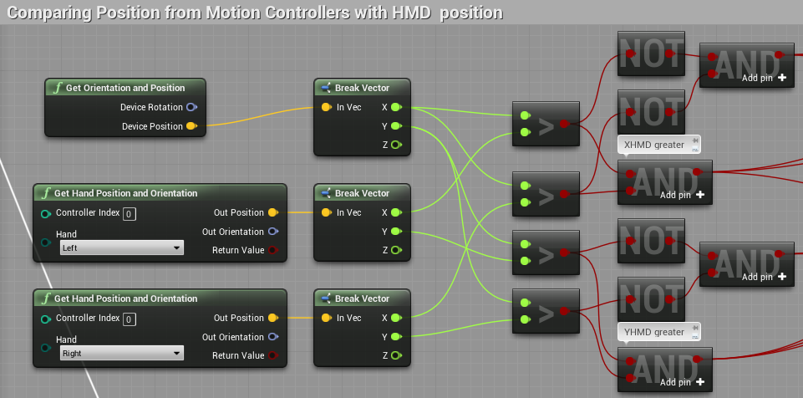

Figure 16 - Comparing position Controllers and HMD

Then we compare if the actual position of the HMD is either greater or smaller to the Y and X Position of the controllers.

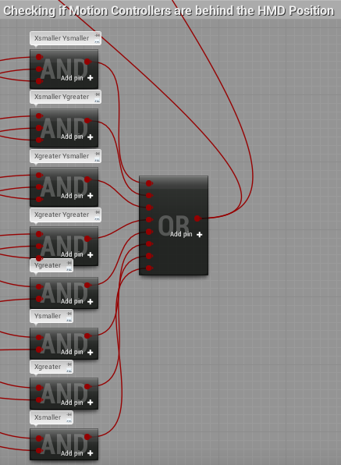

Figure 17 - Are Motion Controllers behind the HMD?

In the third step we put everything together and we activate the Walking by Leaning locomotion if any of the AND’s evaluate to true.

## Scaled Walking

### Concept & Idea

The idea of scaled walking is based on the limited physical space the user has to move, but the virtual space can be a multiple of that space. To be able to use the whole virtual space the physical movements are scaled up, so that the user can explore a multiple of the space of his physical space.

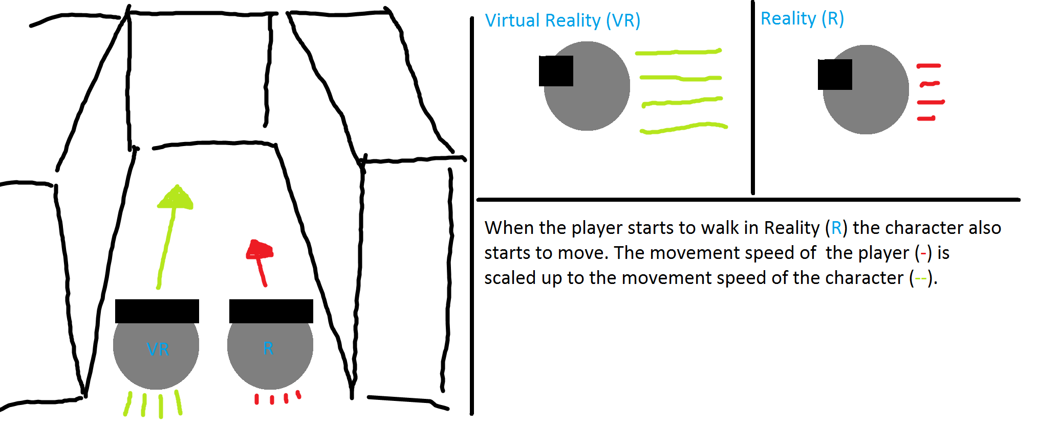

Figure 18 - Scaled walking concept draft

### Parameters

The following parameters are used in this method.

* Speed (movement multiplier)
* Location (HMD)

### Implementation

The difference of the Head Mounted Device location is measured and is then translated into locomotion.

The main question here comes down to when to enable scaling. Other questions that came up during implementation are if it would make sense to implement a gaze direction scaling.

And these values are more critical than in the other movement methods, since the behaviour is coupled with real walking. This results in a distorted image if wrong decisions are made, resulting in motion sickness. It is unclear how to prevent motion sickness with this method.

The Scaling method was left out of the tests, since we have not found a reliable non motion sickness inducing way to move through the virtual world.

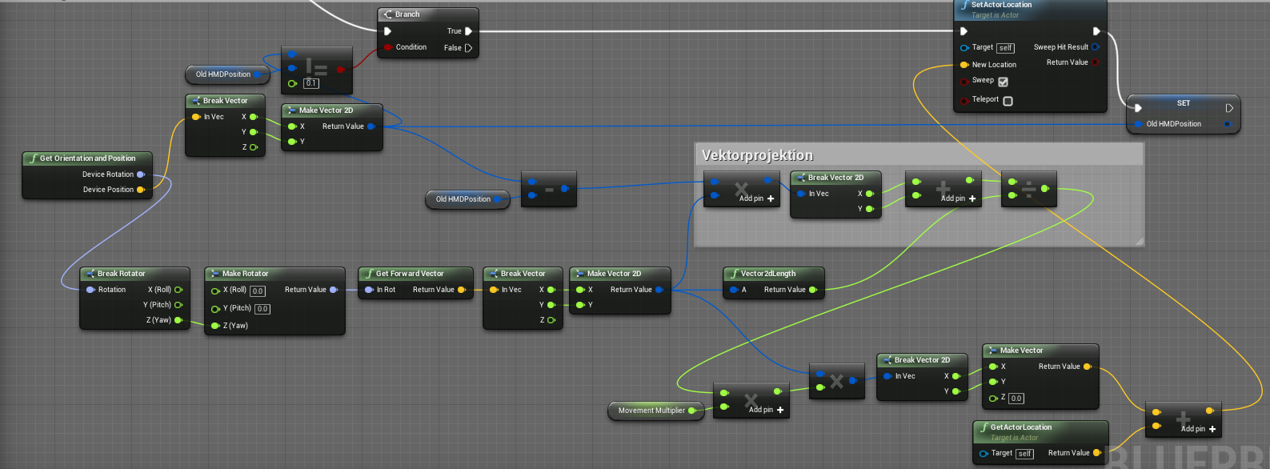We activate this scaling method, when the Head Mounted Device gets moved over a threshold. The method allows only gaze directed movement, which could be interesting for specific use cases. With a large multiplier, large distances can be travelled fast, but only in one direction. This means you need to turn around or implement a method with which you can turn around in the virtual world, so it turns you around in the real world and you can walk further.

Figure 19 - Scaling with vector projection

# Testing

## Introduction

This chapter discusses the testing sequences. What was the scenario, what has been tested and first results will be given. A detailed discussion of the results can be found in chapter *‘6 Conclusion’*.

## Testing Scenario

The tests were hold on three different days with a total of fourteen participants. Each test was divided into five different parts (VR-Experience, Ease of Learning, Pick & Place, Jump’n’Run and Ease of Use). During each of those parts the participant was given a task to fulfilled with follow-up questions to answer. More details to each of those parts will be given in the up following chapters *‘5.3 Experience with Virtual reality’* to *‘5.7 Ease of Use’*.

The HTC Vive setup that we used consisted always of a walking navigation mode [7], that converted 1:1 form the real world to the virtual world, which was composited with the additional user mode. This setup had an area range of 3.5 x 3 m.

The test participants are divided into two groups based on their experience with virtual reality. For this test the participant’s genders are ignored. [2]

## Experience with Virtual Reality

In the first test we wanted to know whether the tested person has had experience with the virtual reality prior to the test. We expected the majority to have already had first contact with the virtual reality. The results showed us that half of the test audience had had experience prior to our testing sequence.

## Ease of Learning

In this test we gave the participants time to get used to each of the four tested navigation methods. They had as much time at disposal as they needed to feel comfortable with the different navigation methods. We expected them to take one to two minutes to get the feeling for each method

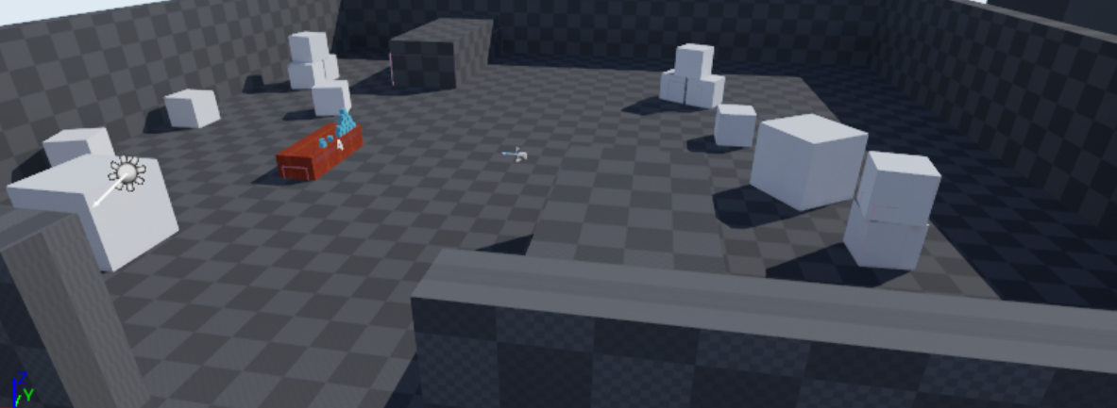

Figure 20 - Testmap Ease of Learning

### Teleport

Chartpair 1 - EoL Teleport

As seen in the charts the average learning time for the experienced and inexperienced participants is approximately the same. However, the times of the inexperienced are closer to the average than the times of the experienced participants.

### Jumping

Chartpair 2 - EoL Jumping

Surprisingly the average learning time of the experienced participants is approximately ten seconds higher than the average of the inexperienced participants. We think this is due to them being surprised on how the method works because they’ve never seen a similar working navigation method.

### Walking in Place

Chartpair 3 - EoL Walking in Place

Comparing both charts it is interesting to see that there is no significant difference between the two testing groups except for two participants of the experienced group spiking either with a low or a higher time.

### Walking by Leaning

Chartpair 4 - EoL Walking by Leaning

The average time of learning of the participants is between 40 to 45 seconds, which is below our expectations. However, without participant eight of the experienced group spiking off, the average of that group would be significantly below the one of the inexperienced group.

## Pick & place

The test persons were asked to pick up a cube, start the timer and reach the other end of the room using the assigned navigation method. This test was done for each of the four navigation method once.

The Pick & Place task was done on four different maps. The participants were told that each map contains three different objects, but asked to not actively search for the objects. Each map has the same base lineout, the only difference being the orientation and the objects placed on the map.

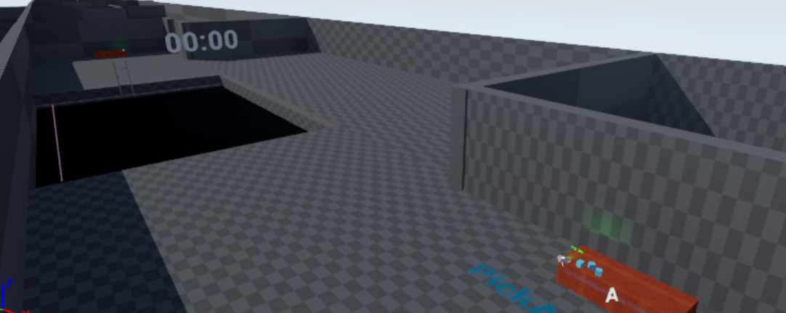

Figure 21 - Testmap Pick & Place

We estimated the following measurements

|  |  |  |
| --- | --- | --- |
| Navigation Method | Time | Objects |
| Teleport | 15 seconds | One object |
| Jumping | 20 seconds | One objects |
| Walking in Place | 30 seconds | Two objects |
| Walking by Leaning | 30 seconds | Two objects |

Table 17 - Expectations Pick&Place

### Teleport

Chartpair 5 - P&P Teleport Time

The averages of the two groups are not comparable due to an outlier (participant 8, with VR experience). Without that outlier the average of the experienced participants would be below the average of the inexperienced. Nevertheless, the averages of both groups are slightly below our expectations of 15 seconds.

Chartpair 6 - P&P Teleport Objects

The average of both groups is slightly below / above one object, which is meeting our expectations. Furthermore, in the experienced group only one participant did not remember any object, while three of the inexperienced group failed to notice the objects.

### Jumping

Chartpair 7 - P&P Jumping Time

The averages of both groups are slightly above our expected time of 20 seconds. While the inexperienced participants are distributed around the average, the majority of the experienced participants are below the average.

Chartpair 8 - P&P Jumping Objects

The average number of objects recognized for the inexperienced is slightly below our expectations. We think this is due to not having worked with virtual reality before and therefore not being able to adjust to the virtual environment just yet. However, there were two participants which exceeded our expectation by recognizing two objects.

The Average of the experienced participants is half an object above our expectations. We were surprised that two participants were able in the short time to recognize all three objects.

### Walking in Place

Chartpair 9 - P&P Walking in Place Time

Both charts are more or less identical with the only difference being the difference between the lowest and the fastest participants.

Chartpair 10 - P&P Walking in Place Objects

Surprisingly and in contrary to the faster navigation methods teleporting and jumping, the inexperienced participants were able to recognize more objects on average than the experienced ones.

### Walking by Leaning

Chartpair 11 - P&P Walking by Leaning Time

The averages of both charts are within two seconds from each other. While the experienced participants are distributed slightly around the average the majority of the inexperienced participants are below the average.

Chartpair 12 - P&P Walking by Leaning Objects

Both groups recognized on average one and a half object, this is below our expectation of two objects per participant. With both groups combined only one participant did not recognize any object, while everyone else was able to at least recognize one.

## Jump’n’Run

In the third part of the test the participants were asked to jump through a pit filled with pillars to the other side. Same as in the ‘Pick & Place’ test they were asked to activate and deactivate the timer at the start and end of the course. Each participant was given three tries to reach the other side of the map.

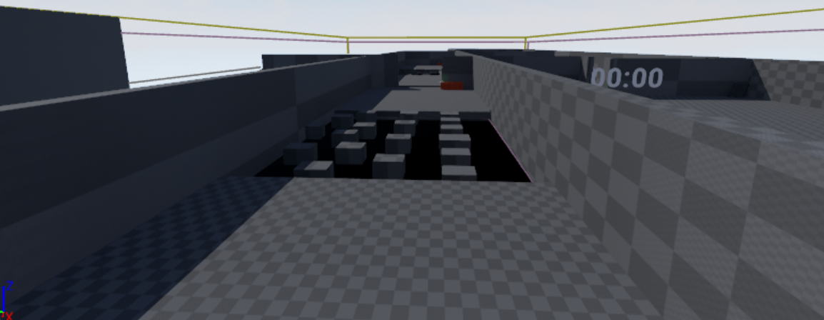

Figure 22 - Testmap Jump'n'Run

We estimated the following measurements

|  |  |  |  |
| --- | --- | --- | --- |
| Navigation Method | Time | Accuracy | Presence |
| Teleport | 15 seconds | 5 | 4 |
| Jumping | 60 seconds | 3 | 2-3 |

Table 18 - Expectations Jump'n'Run

In contrast to the Pick&Place test sequence the time was not really important in this test. And due to each participants having three tries to reach the other side the time lost its validity. Nevertheless, we wanted to measure it just to see how fast the course was possible to be passed through.

As a clarification of the accuracy: The pit contains six pillars in a straight order and various other pillars randomly located in the rest of the pit. The accuracy measures how far the user gets in his three given tries.

We measured that with a scale from one to five with the following specifications:

|  |  |
| --- | --- |
| Scale | Meaning |
| 1 | The user reached the straight pillar one or two |
| 2 | The user reached the straight pillar three |
| 3 | The user reached the straight pillar four |
| 4 | The user reached the straight pillar five or six |
| 5 | The user reached the other side of the pit. |

Table 19 - Clarificaion of the Accuracy scale

### Teleport

Chartpair 13 - JnR Teleport Time

As stated above the time was not a necessity of this test sequence. Most of the participants reached the other side in their first try. Those who took longer fell into the pit and had to start over again. Nevertheless, on average our expectations were met.

Chartpair 14 - JnR Teleport Accuracy

The accuracy of the teleport is as expected at the top of the table. No one failed to reach the other side of the pit.

Chartpair 15 - JnR Teleport Presence

The presence of the teleportation method on average over both groups lies at around 3.5 which is slightly below over expectations. The average of the inexperienced group is with four exactly at our expectation, while the average of the experienced participants with around three is below our expectations. We think this is due to their experience with the teleportation method and virtual reality in general, while the inexperienced participants were overwhelmed with their first contact with virtual reality.

### Jumping

Chartpair 16 - JnR Jumping Time

As stated above the time was not a necessity of this test sequence. Most of the participants reached the other side in their first try. Those who took longer fell into the pit and had to start over again. Compared to the teleport the fastest participant was significantly slower due to the jumping method being not as precise as the teleportation method.

Nevertheless, the average time was only 20 seconds above our expectations. Those fast times are due to participants figuring out that it is easier and faster to jump diagonally instead of jumping straight from pillar to pillar.

Chartpair 17 - JnR Jumping Accuracy

Off all 14 participants only four were able to jump to the other side with their three given tries. On average the participants reached at least pillar three or four. The accuracy is calculated as described in the table in chapter *‘5.6 Jump’n’Run’*.

Chartpair 18 - JnR Jumping Presence

It is interesting to see that the majority of the inexperienced participants rated the presence more negatively than the experienced participants. We think this is due to the fact the inexperienced were expecting a finished product, while those with experience were surprised how cool the method is.

Nonetheless the averages of both groups are only 0.19 (2.66. for the inexperienced and 2.85 for the experienced participants) apart from each other.

## Ease of Use

With this test we wanted to know the participant’s opinion about the usage of the navigation method. Is it complicated or easy to use. To measure we asked them to rate the navigation methods on a scale from one to five.

We estimated the following measurements

|  |  |
| --- | --- |
| Navigation Method | Time |
| Teleport | 5 |
| Jumping | 4 |
| Walking in Place | 3 |
| Walking by Leaning | 3 |

Table 20 - Expectation Ease of Use

Chartpair 19 - EoU Navigation Methods

As expected the ease of use for the teleportation method reached the highest score. We think this is due to the navigation method being very intuitive and the most known navigation method.

The jumping method reached a lower score than our expectations of four. According to the feedback we got during the tests we assume this rating is due to the range indicator being very hard to read. This was an issue especially in the Jump’n’Run test sequence.

The Walking in Place method surprised us with an overall rating of four. We expected the rating to be lower because of the rather inconvenient hand movement and the absence of leg-movement. Furthermore, we assumed that the pressing of the Grip Button would raise the complexity.

The Walking by Leaning method rated between three and four which is slightly above our expectations.

## Problems during testing

During the testing sequences we had different problems.

In one case the test had to be interrupted due to the participant ignoring the chaperone and unplugging the HTV Vive.

Another problem that was noticed is the button of the timer not working properly. In some cases, the participants were not able to stop the time due to the button not responding to their input. We could work around this due to the timer being visible all the time and noting the time the participant tried to stop the time for the first time.

Furthermore, in the Pick&Place test sequence the participants were allowed to see into the room and thus already had the opportunity to recognize certain objects. Surprisingly many did not recognize the objects they could have seen that way.

When walking into a wall with the navigation methods Walking in Place or Walking by Leaning the movement stopped instantly which lead to some participants getting a feeling of motion sickness. Furthermore, they got back shifted when they started to walk again in direction of that object or wall.

A further problem was the imprecision of the jumping method. Which lead to many participants not reaching the other side of the pit with their three tries.

# Conclusion

## Introduction

This chapter discusses our insights about the test results and suggestions for usage.

## Insights

In this place we want to remind that the navigation methods are just compared to each other, the teleportation method is a standard implementation.

We evaluated the four navigation methods from our testing results. These parameters are specified to analyse the differences of a navigation methods in virtual reality [5]. We decided to drop spatial awareness, in favour of the other parameters.

For Walking in Place and Walking by Leaning we only conducted tests for Speed, Ease of Learning, Ease of Use and Information Gathering.

(Scale from one to five, with five being the highest)

|  |  |  |  |  |  |  |
| --- | --- | --- | --- | --- | --- | --- |
| Navigation Method | Speed | Ease of Learning | Ease of Use | Information Gathering | Accuracy | Presence |
| Teleport | 5 | 5 | 5 | 2 | 5 | 3-4 |
| Jumping | 3 | 3 | 1 | 2 | 3-4 | 2-3 |
| Walking in Place | 4 | 4 | 4 | 5 | - | - |
| Walking by Leaning | 4 | 5 | 4 | 5 | - | - |

Table 21 - Quality facters

### Speed

The speed is difficult to measure, since there can be many appropriate velocities for a specific navigation method. This means that instead of just a Walking in Place method there will be a range of speed parameters that will work out in different scenarios. The teleportation method is a really fast navigation method [5]. However, due to that the information gathering and presence may suffer.

### Ease of Learning

The learning times differ on how intuitive a movement method is. If a movement method is implemented intuitive or naturally learning times will decrease.

### Ease of Use

The clear winner is teleportation. However, with some more time invested Walking in Place and Walking by Leaning have potential. As jumping is really difficult to use it needs to be implemented in an accessible and intuitive way, raise the score.

### Information Gathering

The information gathering from Walking in Place and Walking by Leaning is better as the one of teleportation. According to that we conclude that the information gathering of slower navigation methods is better than the information gathering of faster methods.

### Accuracy

With the teleportation method you can navigate very accurately. Jumping on the other hand is not meant for being that precise.

### Presence

Mainly sound was missing, the presence of the teleportation method was better evaluated because it was easier to use.

## Suggested scenarios for Navigation Methods

The scenarios are either for the industry or for recreational purposes.

To make navigation methods as real as possible they have to be integrated realistically, for example that you are exploring on a Segway instead of just flying over the floor.

### Teleportation

In application for the industry our tests show that there is a lot to miss out with by using only teleportation. Therefore, a room-to-room teleportation may be suited to travel between rooms, but other methods should be used to explore the rooms.

### Jumping

Generally suited for Jump’n’Run style games. The implementation as it is right now is made with a single teleportation inside the jumping. However, the jump could also be fully locomoted and therefore the motion is felt. The motion sickness needs to be evaluated.

### Walking in Place

In this method the controllers are used to navigate. If the controllers are used for something else when the user needs to navigate he can’t really navigate. This could be used for exploring rooms without much of movement necessary other than the arms. Can be used to retain spatial knowledge. [9[

### Walking by Leaning

Only leaning required, which is a great thing. As it is very similar to the Walking in Place method it can be used to retain spatial knowledge. [9]

## Conclusion

There is not much experimenting with movement methods going on in the games that are publicly available. Instead you see the same kind of navigation methods in every game. The first suggestion we’ve got out of our resources that there is no fit them all navigation method, there is no navigation method that will work best with all different scenarios.

In game design you could easily introduce a navigation method first, and base the game itself on the navigation method, so that the game fits itself around the navigation method.

A developer could come and take a look at the quality factors, so that if he wants to make an virtual reality application that requires speed and precision he can choose teleportation as his favoured methods. When he’s looking to create an application where you need to find objects Walking in Place or Walking by Leaning is more in favour.

# Further Steps

## Introduction

This chapter discusses various topics that could have been implemented into the project. Those topics could be implemented in a further project.

## Marketplace UE4 / Unity3D

The possibilities to create navigational assets for Unreal Engine 4 or Unity3D would help to drive the community forward, instead of just creating an asset and throwing it out there it should be researched first what is already available from the community. And then you could think about extending what is already there with what you have in mind.

## Graphical Navigation Menu / UI

A Graphical Navigation Menu should be implemented such that Users can handle the product when they come in first contact with it, so that no explanation is necessary. There is also a possibility to explain how the different methods work, e.g. with videos integrated in the UI.

## Composition of Navigation methods

The combination of different navigation methods could create composite movement methods that are put together because of their contrary strengths and weaknesses. E.g. a teleportation method that is accurate, combined together with a less accurate movement method like walking in place, which is a fast reacting movement method, in contrary to the teleportation method.

## Teleportation – turn when meeting chaperone

In the first picture we see the user in the Real World, with the HMD on, he will then use the Chaperone Teleport Movement Method and stands within the activation area (see picture below), this means that the Chaperone Teleport is active. Otherwise normal teleportation is active.

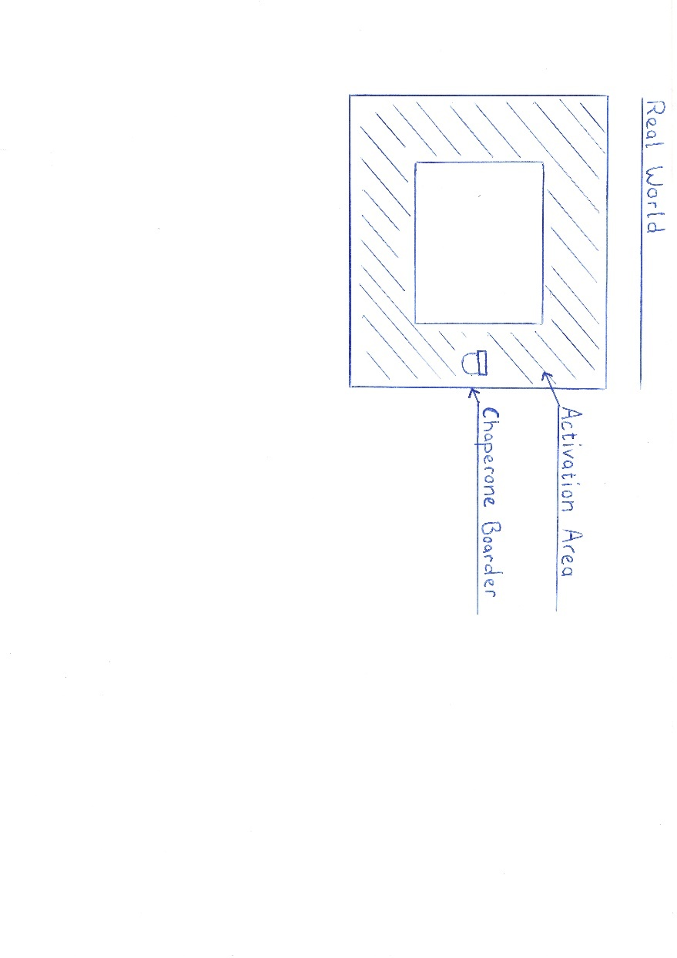

Figure 23 - Chaperone Actication Area

If the Chaperone Teleport is within the Teleportation Area (see picture below), then the Virtual World will turn so that the virtual world boarder is moved to the Chaperone Boarder. So that if the user moves by walking he will move away from the Chaperone Boarder.

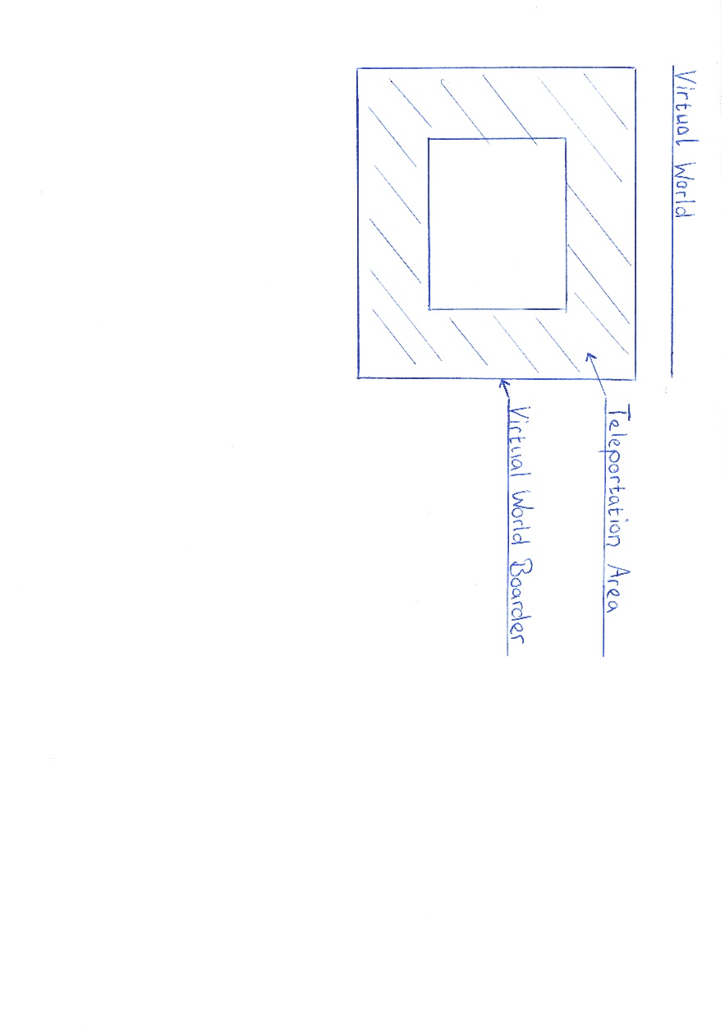

Figure 24 - Teleportation Area

## Deceleration when close to walls and obstacles.

Deceleration and other Feedback when being to near to virtual walls can be used, to create an immersive feeling that there is a wall. At this very point of the implementation the user is shifted back to another position when colliding with a wall, these effects should be minimized as much as possible when, wall collision is enabled.

# Reflection

## Introduction

In this chapter we reflect on our project work. We will talk about what we have learned / gained, what was good or bad and our time management. Furthermore, we will reflect on the collaboration within the team and with the coaches.

## Lessons Learned

### Dominic Bär

During this project I learned how important a well-constructed time management is while constantly work on a project. To plan and estimate how long it takes for each task to be finished and to calculate enough slack time for unexpected incidents are the key components for a successful time management.

Prior to the project I had no knowledge and experience working with the used game engine UnrealEngine4. After working with the engine for half a year now I cannot say that I mastered the creation of applications with the engine but that I learned at least the basics on which I can build up and further expand my knowledge. Nevertheless, I am still at the beginning on learning the potential and possibilities of the engine.

The testing was another problem we stumbled upon. At first we did not know, what and how we want to test the prototype and how much time and participants are needed. We knew that many of our colleagues were interested in testing since during the semester we were asked a lot if they could come to test and play some virtual reality games. This told us that we had interested people and that it would not be that hard to get a decent number of test participants. However, for a further project it would be necessary to know what and how you want to test while you are implementing. This would have saved us a lot of time.

Working with Marcel was nothing new for me. We worked together in the projects one and two and got to know each other and how each of us works there. During the project he was very understanding and helped me a lot with the UnrealEngine4 problems, to understand them and to be able to fulfil my part.

### Marcel Groux

I enjoyed learning the UnrealEngine4 a lot. It was nice to get used to program with the HTC Vive and the UnrealEngine4, since there isn't that much documentation around.

There were always these strange jumps in development, as soon as we knew how to implement something it was implemented instantly in comparison to getting the know-how, which took a lot more time.

The workflow of putting the headset on and testing some navigation method, and putting it down again and putting it on again is really distracting, there are workarounds, but they are slow and annoying. I ended up strapping the HMD on and off every 10 minutes or less when I was testing methods out.

Getting used to the HTC Vive was a time consuming part, it sometimes was not working, and we needed to learn what to do when it wasn't working, after an update for the base-station I ended up reloading older firmware to the base-station, because one of them wasn't functioning properly. As we worked extensively with the HTC Vive, we shouldn't have taken for granted that it will always work.

Meanwhile the project I did had a lot of errors. It would've been better to finish the small work and then move on, but I didn't want to do the small tasks because I thought there were other priorities (challenges) that are more important or dangerous to not leave them back out unconsidered. This was an error, instead of searching for new challenges I should finish the obvious things first, this would have given me new challenges I couldn't foresee.

It comes down to the following famous quote: "Start by doing what's necessary; then do what's possible; and suddenly you are doing the impossible." -Francis of Assisi. This is my workflow from now on.

In the project week we struggled and we were behind schedule after the first day. We should have instantly re-evaluated the situation and decide to slow the process down at least at the beginning, so we could've helped out each other. This was a big error. Deadlines that were missed during the project week, weren't right away re-evaluated. In retrospect, we should have talked right away with each other.

Later I found out that testing needs a lot of time, there is a lot to do in the preparation of the tests and also in the evaluation of the tests. I'm very grateful that we could plan and fix dates quickly, so that we could test in the same week when we were ready. In the future we should fix dates and invite people earlier, so that the timeslots we have are fully saturated.

Dominic is a forthcoming person, I enjoyed working with him a lot! I'm really grateful for all the work that he did and I'm proud to have done my part for this project.

## Time Management

Regarding the time management, we had difficulties to really estimate the needed time for the different tasks. Most of the difficulties with estimating the time for the project were based on the inexperience in the technologies. Especially hard was the calculate the time for the induction of the UnrealEngine4 and other virtual reality aspects since we did not know how effortful these tasks can get. Another difficulty was the at the beginning not defined navigation methods and the not yet clearly defined project goals. Those changed during the project when the prototype took its shape and everything was clearly defined in the project agreement. Furthermore, we had forgotten to include enough slack time in our management which lead to intensified workload during the last few weeks of the semester.

For further projects we think the time management is one of the most important tasks of planning a project and the first step to success. Our own time management clearly needs to improve.

## Collaboration

### Team Internal Collaboration

Due to working together in the projects one & two we already knew how the other person was working and thus it was quite easy to get used to it again.

With the daily maintained Trello board we were able to get a structure in the project and an easy way to assign the various tasks to the better fitting person. In the end we divided the whole project into two parts, a theoretical and a practical to fit the personality and preferences of each of us.

### Collaboration with Coaches / Clients

The collaboration with Simon Marcin and Stefan Arisona was fine. Every week we had a meeting where we shortly discussed the progress of the project. They were motivated to give useful feedback and inputs to help us improve our work. The communication with them was very reliable.

### Collaboration with the ‘Explorative Navigation in Virtual Reality’ project team

We were able to share thoughts and ideas with Michael Läuchli and Stefan Mettler of the ‘Explorative Navigation in Virtual Reality’ project team. During the project week in the middle of the semester we shared the MediaLab and the HTC Vive to work on our projects and thus were able to collaborate by sharing insights and ideas.

# Index of Literature

L1. Internet

[1] M. Ward, R. Azuma, R. Benett, S. Gottschalk, H. Fuchs. A Demonstrated Optical Tracker With Scalable Work Area for Head- Mounted Display Systems. *Department of Computer Science Sitterson Hall University of North Carolina Chapel Hill*, NC 27599-3175

[2] S. Bendiksen, L. Jorgensen. Balancing the virtual reality experience. *Nord-Trondelag University College*

[3] R. Pausch, J. Snoddy, R. Taylor, S. Watson, E. Haseltine. Disney’s Aladdin: First Steps Toward Storytelling in Virtual Reality. *University of Virginia, Walt Disney Imagineering.* 1996 ACM-0-89791-746-4/96/008

[4] B. E. Riecke, B. Bodenheimer, T. P. McNamara, B. Williams, P. Peng, D. Feuereissen. Do We Need to Walk for Effective Virtual Reality Navigation? Physical Rotations Alone May Suffice. *Vanderbilt University, Nashville, TN, USA, Simon Fraser University, Surrey, BC, Canada, Rhodes College, Memphis, TN, USA.* Spatial Cognition 2010.

[5] D. A. Bowman, D. Kollder, L. F. Hodges. Travel in Immersive Virtual Environments: An Evaluation of Viewpoint Motion Control Techniques. *Georgia Institue of Technology.* 1997 IEEE

[6] J. J. LaViola Jr., D. A. Feliz, D. F. Keefe, R. C. Zeleznik. Hands-Free Multi-Scale Navigation in Virtual Environments. *Brown University Department of Computer Science*. ACM 2001 1-58113-292-1/01/01

[7] M. Usoh, K. Arthur, M. C. Whitton, R. Bastos, A. Steed, M. Slater, F. P. Brooks Jr. Walking > Walking-in-Place > Flying, in Virtual Environments. ACM 1999 0-201-48560-5/99/08

[8] S. Frees, G. Drew Kessler. Precise and Rapid Interaction through Scaled Manipulation in Immersive. *Virtual Environments. IEEE Virtual Reality 2005*

[9] S. Regillus, E. Folmer. VR-STEP: Walking-in-Place using Inertial Sensing for Hands Free Navigation in Mobile VR Environments. *University of Nevada*. 2016 ACM. ISBN 978-1-4503-3362-7/16/05

[10] M. Slater, M. Usoh, A. Steed. Taking Steps: The Influence of a Walking Technique on Presence in Virtual Reality. *University of London*. 1995 ACM 1073-0516/95/0900-0201

L2. Existing Projects

We built up on an existing project, that already implemented movement methods, we decided to take over the teleportation method that was already implemented, and programmed our own additional navigation methods.

The project can be found under the following address:

<https://bitbucket.org/mordentral/vrexppluginexample>

# Index of Figures

## Figures

Figure 1 - Jumping concept draft 14

Figure 2 - Measuring Time 15

Figure 3 - Creating an array of ZValues 15

Figure 4 - Iterating and Evaluating 16

Figure 5 - Jump Height Detection 16

Figure 6 - Jumping height detection 16

Figure 7 - Mulltiplier dependent on HMD pitch 17

Figure 8 - Spawning a target indicator 17

Figure 9 - Walking in place concept draft 18

Figure 10 - Activator Walking in Place 19

Figure 11 - Start Walking in Place 19

Figure 12 - Access Hand Position 20

Figure 13 - Calculation of new location 20

Figure 14 - Walking by leaning concept draft 22

Figure 15 - Finding the forward vector of the HMD 23

Figure 16 - Comparing position Controllers and HMD 23

Figure 17 - Are Motion Controllers behind the HMD? 24

Figure 18 - Scaled walking concept draft 25

Figure 19 - Scaling with vector projection 26

Figure 20 - Testmap Ease of Learning 28

Figure 21 - Testmap Pick & Place 30

Figure 22 - Testmap Jump'n'Run 36

Figure 23 - Chaperone Actication Area 45

Figure 24 - Teleportation Area 46

## Tables

Table 1 - Description of the navigation method properties 4

Table 2 - Properties of Pointed Teleportation 5

Table 3 - Properties of Jumping 5

Table 4 - Properties of Walking in Place 5

Table 5 - Properties of Walking by Leaning 6

Table 6 - Properties of Scaled Walking 6

Table 7 - Properties of Walking 7

Table 8 - Properties of Dynamic Walking 7

Table 9 - Properties of Auto Walking 8

Table 10 - Properties of Walking by Button 8

Table 11 - Properties of Gaze-directed Teleportation 8

Table 12 - Properties of Room-to-Room-Teleportation 9

Table 13 - Properties of Zoomed Teleportation 9

Table 14 - Properties of Climbing 9

Table 15 - Properties of Flying 10

Table 16 - Properties of Flying II 10

Table 17 - Expectations Pick&Place 31

Table 18 - Expectations Jump'n'Run 36

Table 19 - Clarificaion of the Accuracy scale 36

Table 20 - Expectation Ease of Use 40

Table 21 - Quality facters 42

## Chartpairs

Chartpair 1 - EoL Teleport 28

Chartpair 2 - EoL Jumping 29

Chartpair 3 - EoL Walking in Place 29

Chartpair 4 - EoL Walking by Leaning 30

Chartpair 5 - P&P Teleport Time 31

Chartpair 6 - P&P Teleport Objects 32

Chartpair 7 - P&P Jumping Time 32

Chartpair 8 - P&P Jumping Objects 33

Chartpair 9 - P&P Walking in Place Time 33

Chartpair 10 - P&P Walking in Place Objects 34

Chartpair 11 - P&P Walking by Leaning Time 34

Chartpair 12 - P&P Walking by Leaning Objects 35

Chartpair 13 - JnR Teleport Time 37

Chartpair 14 - JnR Teleport Accuracy 37

Chartpair 15 - JnR Teleport Presence 38

Chartpair 16 - JnR Jumping Time 38

Chartpair 17 - JnR Jumping Accuracy 39

Chartpair 18 - JnR Jumping Presence 39

Chartpair 19 - EoU Navigation Methods 40

1. Attachment
   1. Project Agreement

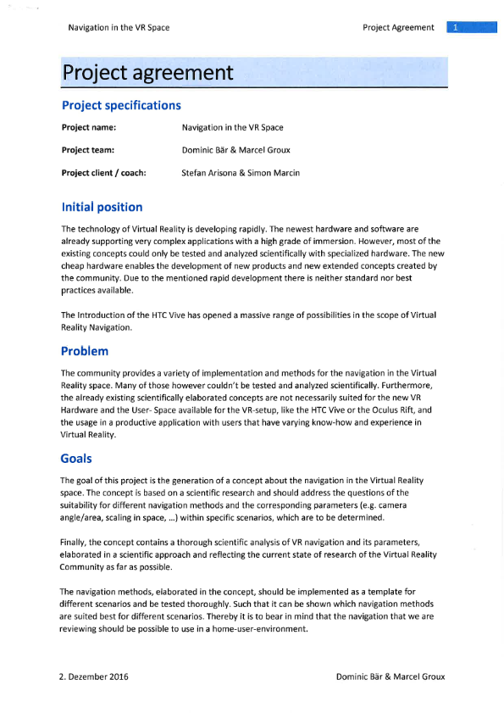

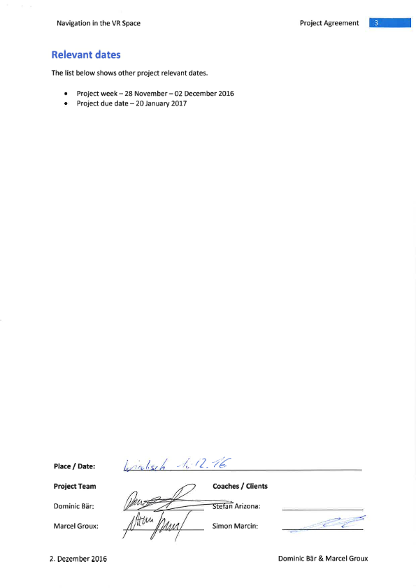

* 1. Test Procedure

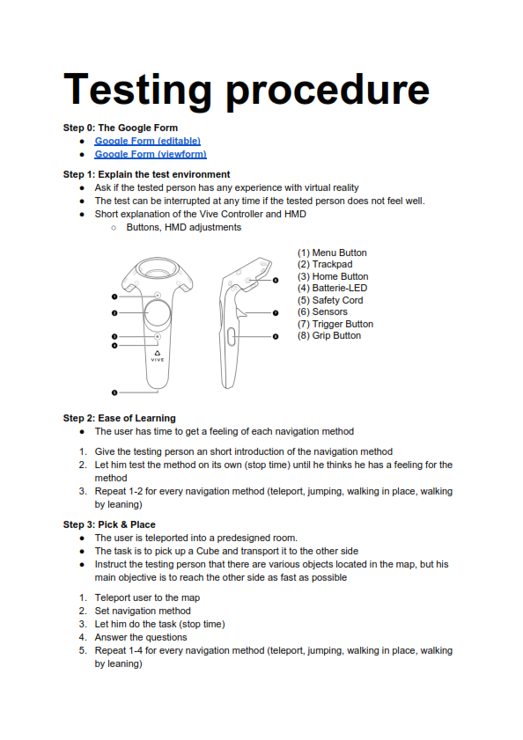

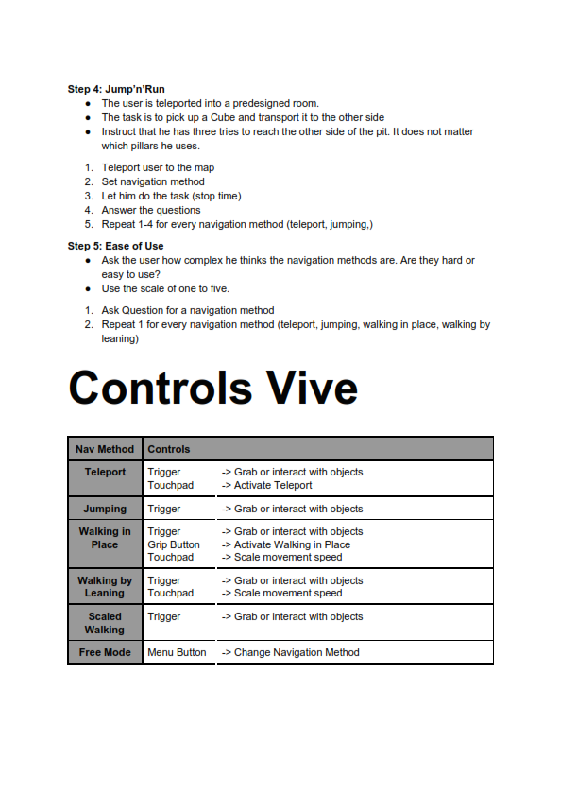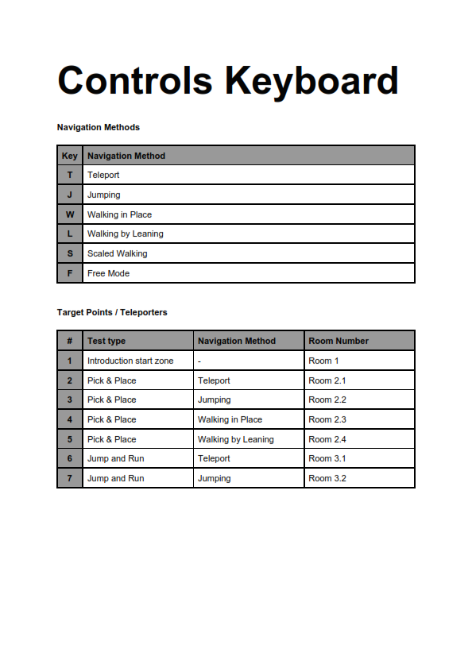

* 1. Testing Survey

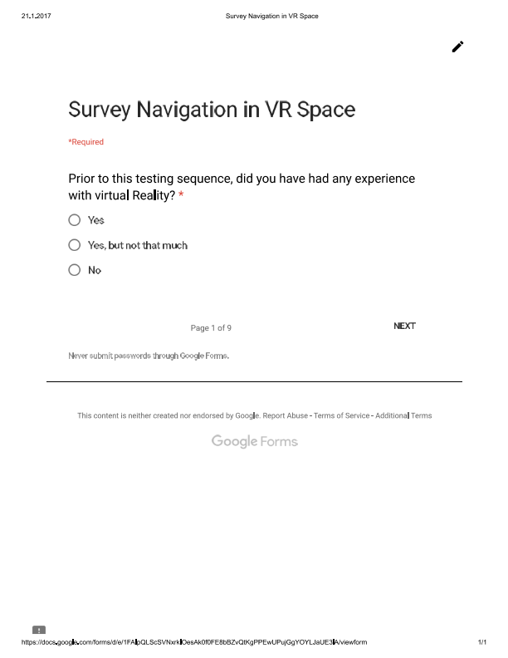

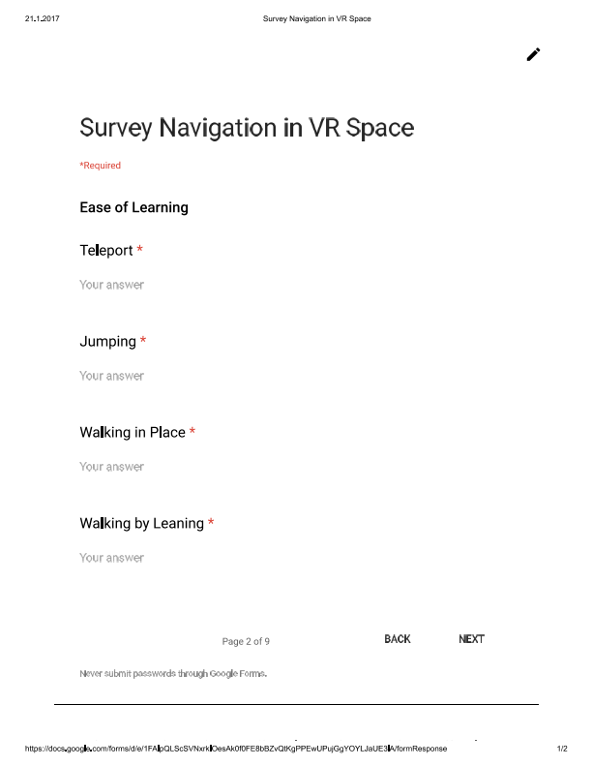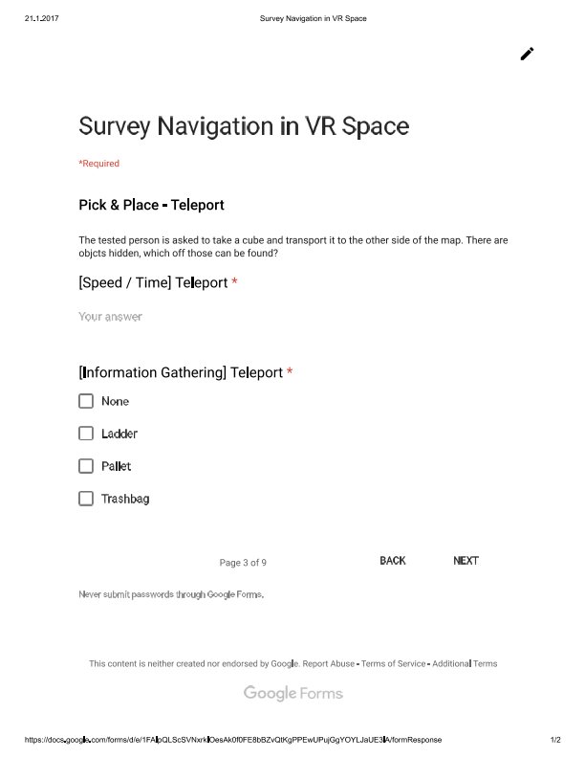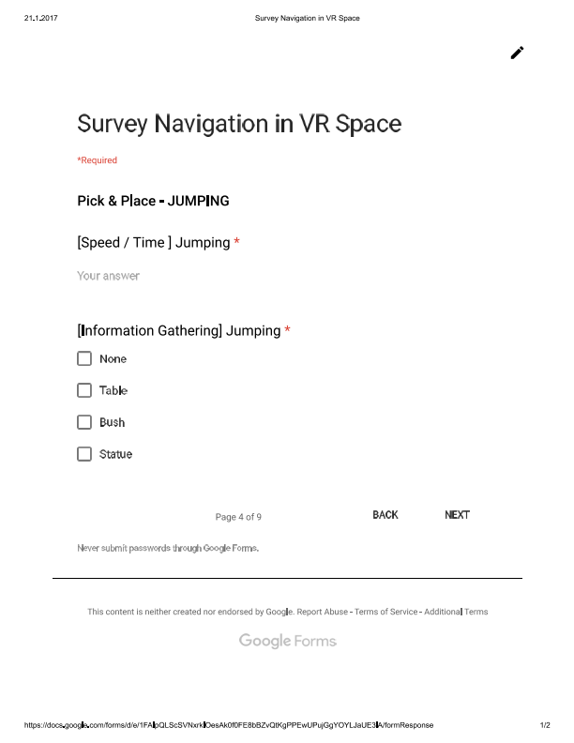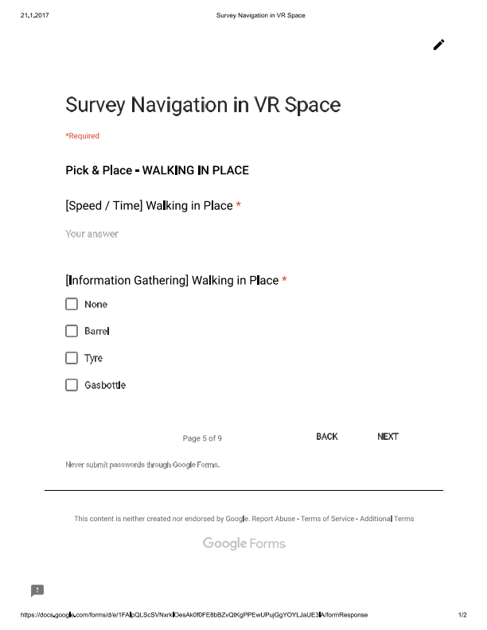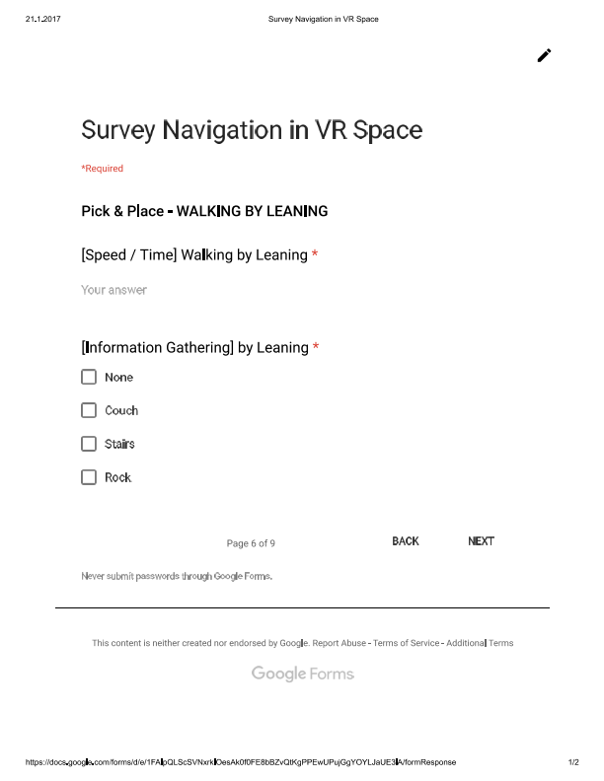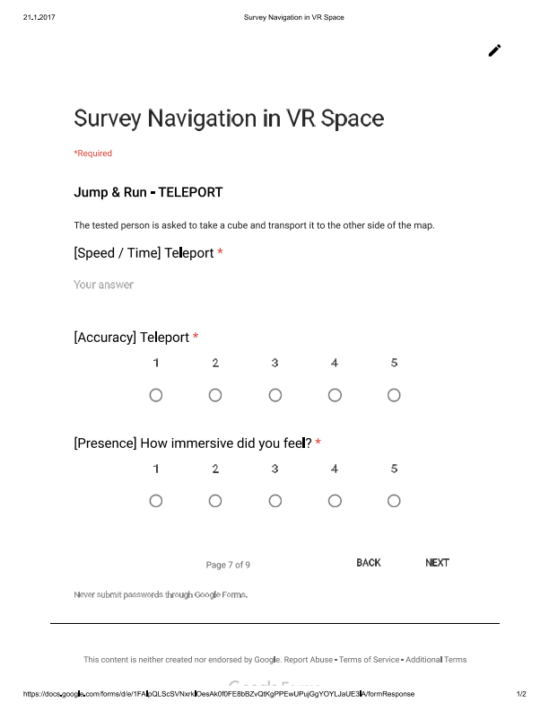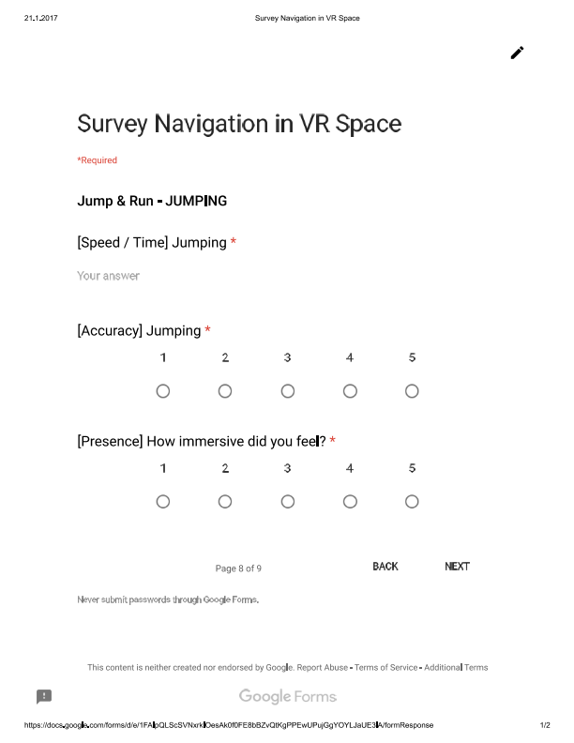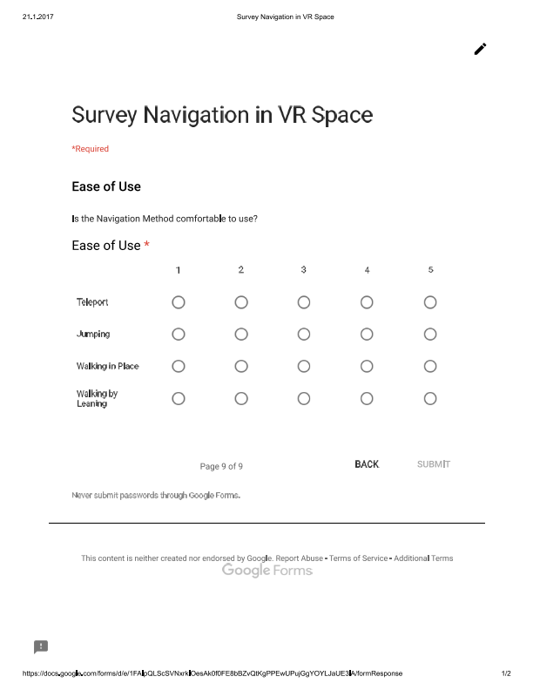

* 1. Testing Survey Results
     1. Ease of Learning

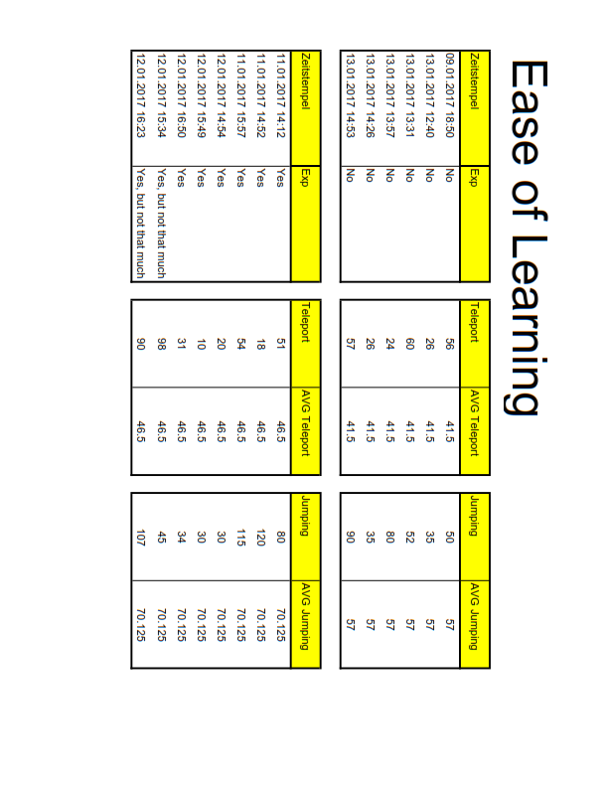

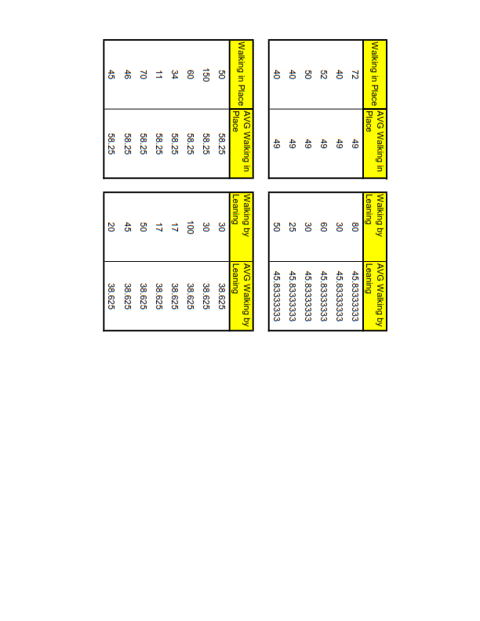

* + 1. Pick & Place

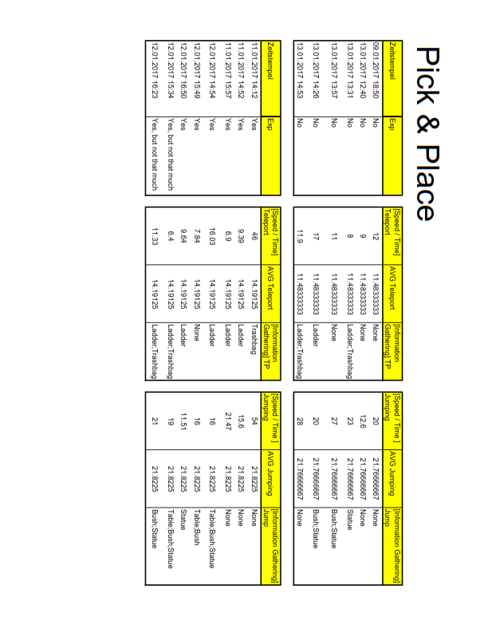

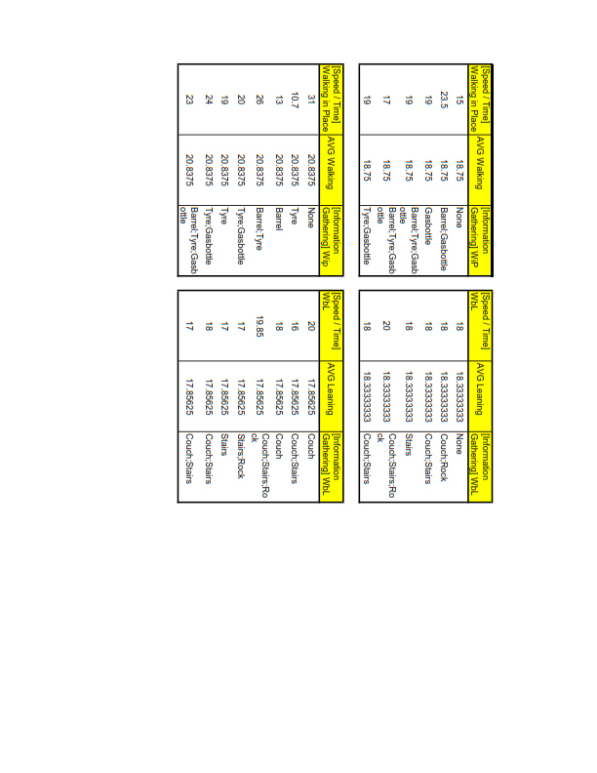

* + 1. Jump’n’Run

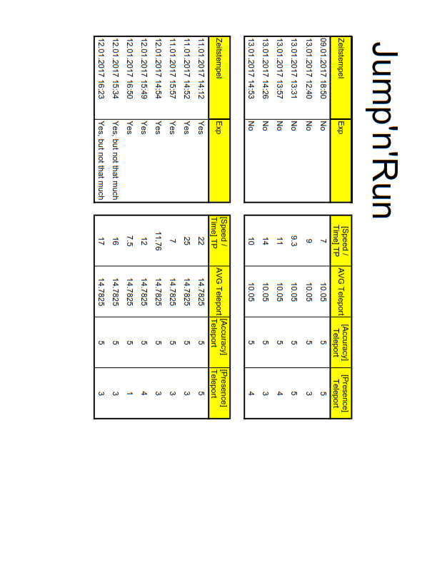

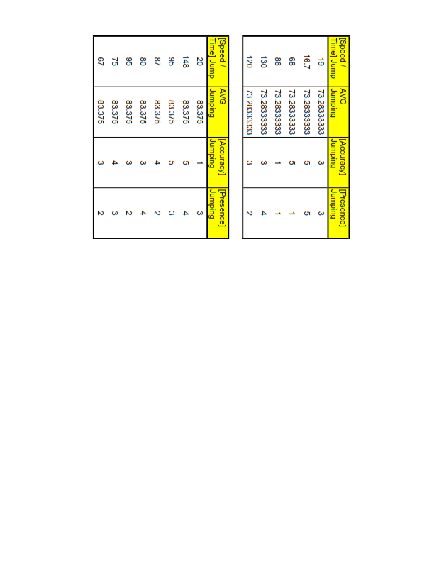

* + 1. Ease of Use

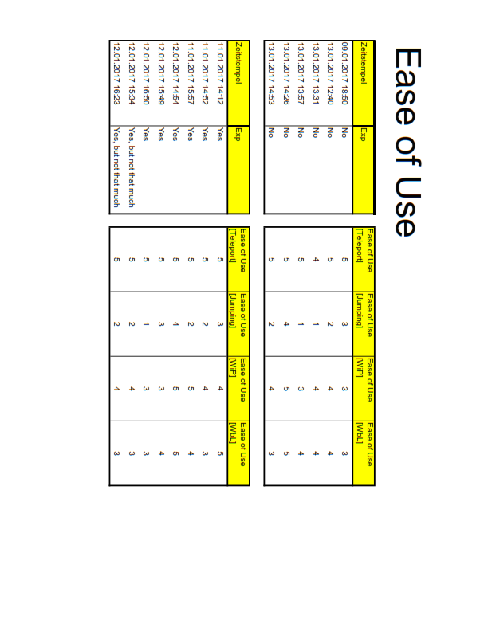

1. https://unity3d.com